Film loop performances, installations and multi-projector works.

The late emergence of film makes it difficult to distinguish between technique and technology as clearly as is possible in music. (Adorno, Transparencies on Film).

The imagery in a number of animated multi-projector 16mm film-performance works has often consisted of repeating –looped- abstract graphic shapes or flicker patterns that generate quasi-kinetic movement. Prominent in this field is Bruce McClure, whose films are composed of simple patterns of black and white, produced by the bleaching of selected frames on strips of black 16mm spacing, according to a numerical system. As such, they might seem to follow in the footsteps of Peter Kubelka and Tony Conrad, whose respective films Arnulf Rainer (1960) and The Flicker (1966) arguably established the sub-genre. Crucially, however, and in strong contrast to these paradigms, McClure works with film technologies that are modified to such an extent that his works are arguably not films in any usual sense. His performances are important for the way in which they probe the necessary and sufficient conditions for something to actually be a film, through a disruptive questioning of what film movement is, via image-generated sound relations, which, though mutually dependent in a technical sense, are affectively disjunctive. Also considered here as important precursors are Guy Sherwin’s optical sound films, especially Cycles 3 (1972-2003) in which something inanimate is animated in such a way that the means by which the re-animation occurs is a feature of the work, at once transparent -didactic almost- yet at the same time continually surprising and mysterious in the experience. The portmanteau word ‘Inanimation’ identifies a form of quasi-movement, something between conventionally illusionistic animation (@24 or 25fps) and the clearly static sequences of discrete images that form an animatic sequence at eight or fewer images per second.

The resurgence of expanded work, involving live elements including performance, has broad parallels with the emergence of the Expanded Cinema of the London Filmmakers’ Co-op in the 1970s. A variety of factors have contributed to this development. The broader context includes resistance to the demise of film (though at the time of writing this demise is moving in reverse, at least in some respects). While Tacita Dean notably mounted a high-profile campaign to try to keep 16mm colour printing available in the UK, there has been a World-wide growth in artist-run film labs devoted to processing and printing, an activity that was never very profitable for the commercial labs, as the same amount of work was required to produce something which could not be sold for anything like the price of its 35mm equivalent, whereas the latter continues to be profitable. 1. The availability of relatively cheap 16mm projectors has facilitated the proliferation of multi-projector works, something that was less common in ‘70s expanded cinema, when projectors were more in current commercial and educational use and hence a lot more expensive to buy2.

While much of the original expanded cinema was concerned with materialist interrogations of the nature of temporal and spatial structures, and with exposing the ideological underpinnings of the technology, with the screen surface and viewer positioning, a lot of recent work has been more synthetic and audio-visual (to the extent of even resembling son et lumière presentations, though on a much smaller scale), produced by groups as often as individuals, typically using found footage that acquires a surreal character when appropriated; old industrial, scientific and, especially, educational films, projected through colour filters and accompanied by live music. The use of this kind of content arises from there being vast stocks of such films available cheaply, but equally the use of loops means that works can be made with very small quantities of film stock, which can be processed and printed easily at home, using a proprietary tank and a camera as a printer, in the manner of early cinema production processes.

However, whereas the foregoing uses found footage more or less as content, deployed in the service of image-centred manipulations, McClure extends the original analytical project typified by the work made at the LFMC, specifically in reconfiguring the relationships between the various parts of the film technology, principally the celluloid strip and the projection device, to develop a critical practice that pushes the technical parameters of the medium to the point where the question arises of whether what we are experiencing is still a film. McClure’s works are much more tightly structured and are strictly frame-based. Image content, when there very occasionally is any, is de-emphasised, dominated by structure and pattern, in which simple, camera-less film strips are used. Repetition is crucial in delimiting the scope of what will be seen, but with the simultaneous expectation that the combination of these limited elements will generate something surprising and unexpected: the visible components are explicitly restricted to very simple forms –rarely more than deformed rectangles of light- but in such a way that expansive complexities generated by the interplay of screens and image-sound relationships are given focus.

Since 1971, Guy Sherwin has been producing films in which the image generates the optical soundtrack. This continues today in the Vowels and Consonants (2005-) series of performances, created with Lyn Loo. Sherwin’s Cycles (1972) was made by punching holes into grey leader and sticking paper dots onto it to make a rhythmic sequence in which the one-second intervals between each circular 'image' gradually decrease until the holes and dots occupy all the frames of the film. The optical soundtrack is produced at the same time using segments of paper dots, which were stuck to the soundtrack area of the film. This sequence is then repeated in reverse to make a complete cycle lasting approximately two minutes. In 1977 a secondary rhythmic layer was added to the original film by printing two of these cycles through a varying aperture so that the static grey 'background' is transformed into waves of light and dark. All this work was undertaken by Sherwin himself, using the Debrie contact printer at the London Filmmakers’ Co-op.
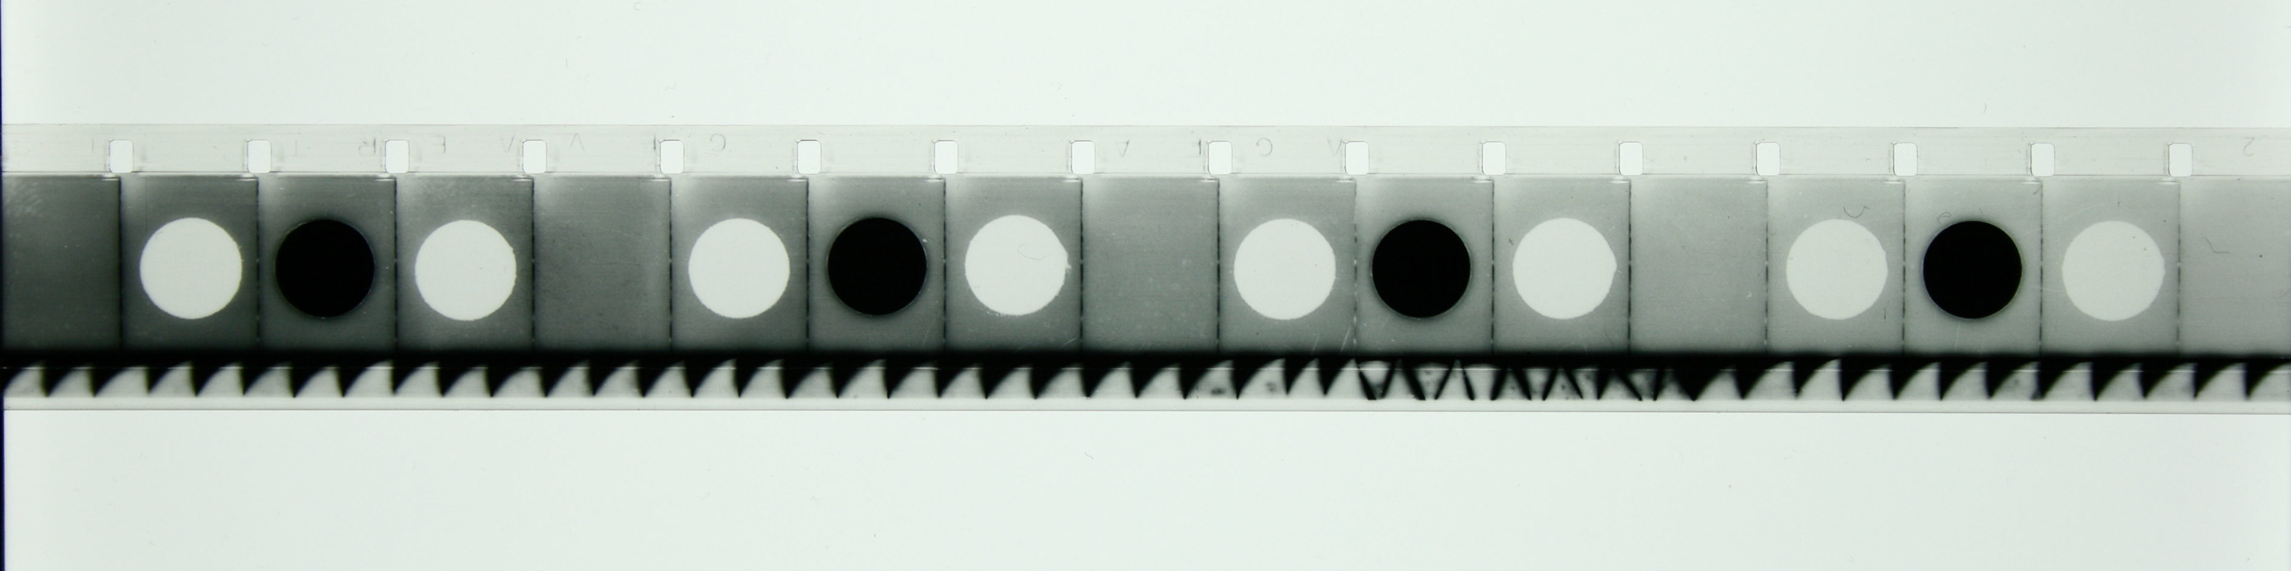
Image 1: Cycles. Photo: Guy Sherwin.
Cycles #3 was made in 2003 by taking two identical prints of Cycles and using two projectors to project them out of phase by about one minute, so that one film is decelerating while the other is accelerating. The projected images are placed one inside the other with the second projection slightly larger and with an amber cast from a piece of colour acetate placed over the projector lens. (Adapted from Sherwin’s notes).

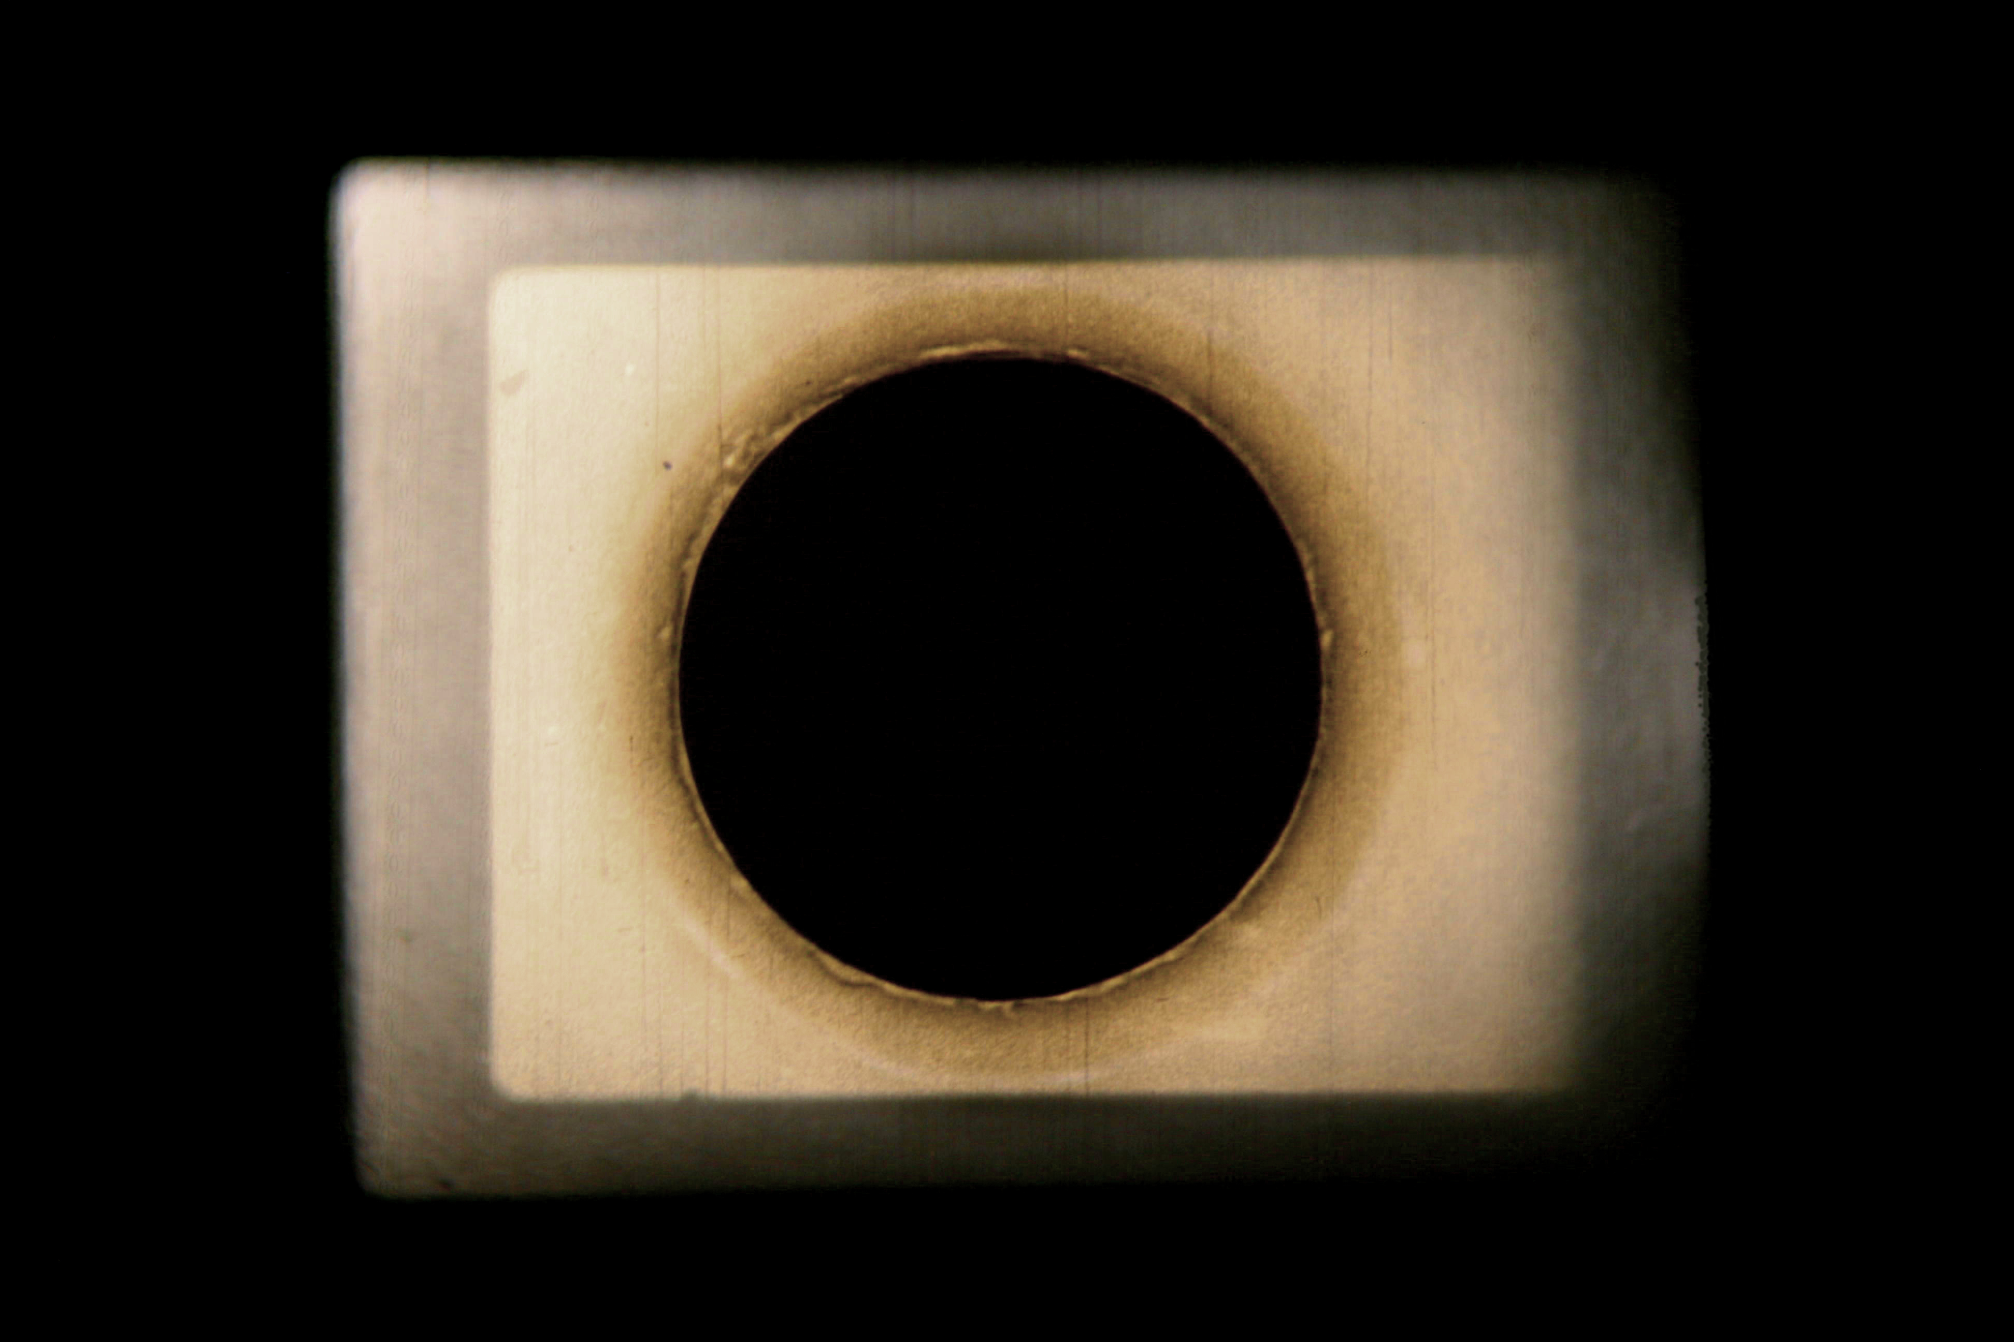
Image 2: Guy Sherwin Cycles 3, Photo: Guy Sherwin.
In performed versions, live interventions are made by shifting focus on the projectors, or by changing the relative volume and timbre of the two optical soundtracks. This further complicates the work, in which one experiences an unstable rhythmic form, which, though explicitly generated by a repeating circular shape, pulsates and seems to expand and contract. Although, as in the aforementioned flicker films, there are strong contrasts between adjacent frames, the experience is very different, since the rhythms generated by the superimpositions of two projections moving in and out of phase create a pulsating continuity: the kinetic effect is more constant, also because the differences between frames is not maximal, as it is in the classic flicker films. What one sees appears as something somewhere between flicker and illusory movement. The work waxes and wanes between the two and the degrees of apparent continuity vary depending on the shifting interplay between the two layers. Thus Cycles 3 generates a more unpredictable experience for the viewer partly because the work is not fixed, but is different every time it is shown, depending on how the two layers interact. This in turn is dependent partly on the time gap between the first and second film starting, and partly on the fact that no two projectors run at exactly the same speed, in strong contrast to the fixed structure of the flicker film. The balance between image and sound, however is roughly equal regardless, insofar as both are given equal weight, in contrast to much of McClure’s work, where sound has come to dominate almost totally in some recent work, as discussed below (3).
Another (non-looping) precursor is Lis Rhodes’ iconic black and white, two-projector film Light Music, created in 1975 and since canonised by its inclusion in a show in The Tanks at Tate Modern in 2012-13. The imagery consists of arrays of moving horizontal bands of varying widths and thicknesses, which also generate the optical soundtrack. In Light Music, both images can’t really be viewed simultaneously because they are projected facing each other on opposite walls, however the sound emanating from the two sources mixes in the space and the ear dramatically, generating notable phasing patterns, compounded by the highly reflective raw concrete surfaces of the Tanks. There is a sense that what we see in these works by Sherwin and Rhodes is something bolder and more disruptive than in animation, or movies generally, because a movement-effect is generated from what are clearly not conventionally filmed footage, where, in the process of examining a length of celluloid by eye, it can be seen how movement will come to be generated from a series of near-identical frames.

At least since Kubelka’s Arnulf Rainer (1960), it has been understood that alternating black and white frames don’t generate illusionistic movement in the eye of the viewer, even though the experience cannot but be described as somehow kinetic. Insofar as they create a flicker effect, they return us to the early ‘Flicks’, in which, when projected with a single bladed shutter at around 16 fps, there is a pronounced flicker. In Kubelka’s film, alternating frames of black and white are occasioanlly flashing at a rate of twelve per second and in Tony Conrad’s The Flicker (1966) for much longer periods.

Since 1995 the Brooklyn-based artist McClure has been making 16mm ‘Projector Performances’ that also use flicker patterns, however these form part of an apparatus featuring modified 16mm projectors, such that the work is very different from its forebears. McClure has made over seventy works in which the projector forms the irreducible core and motor of the experience:

‘When I came to the projector it was already becoming an ageing metaphor; a forlorn morphology receding on a horizon of cinematic impulses. Ignoring its déclassé status, I appreciate its limits, auditioning with it tirelessly in mock executions’4.

McClure’s approach to the technology referred to above was crucially inspired by John Cage’s short essay The Future of Music: Credo5. In this manifesto-like critique of the conservative ends to which potentially revolutionary electronic instruments were being put, Cage vigorously criticises, for example:

‘Thereministes (who) did their utmost to make the instrument sound like some old instrument, giving it a sickeningly sweet vibrato, and performing upon it, with difficulty, masterpieces from the past’ 6.
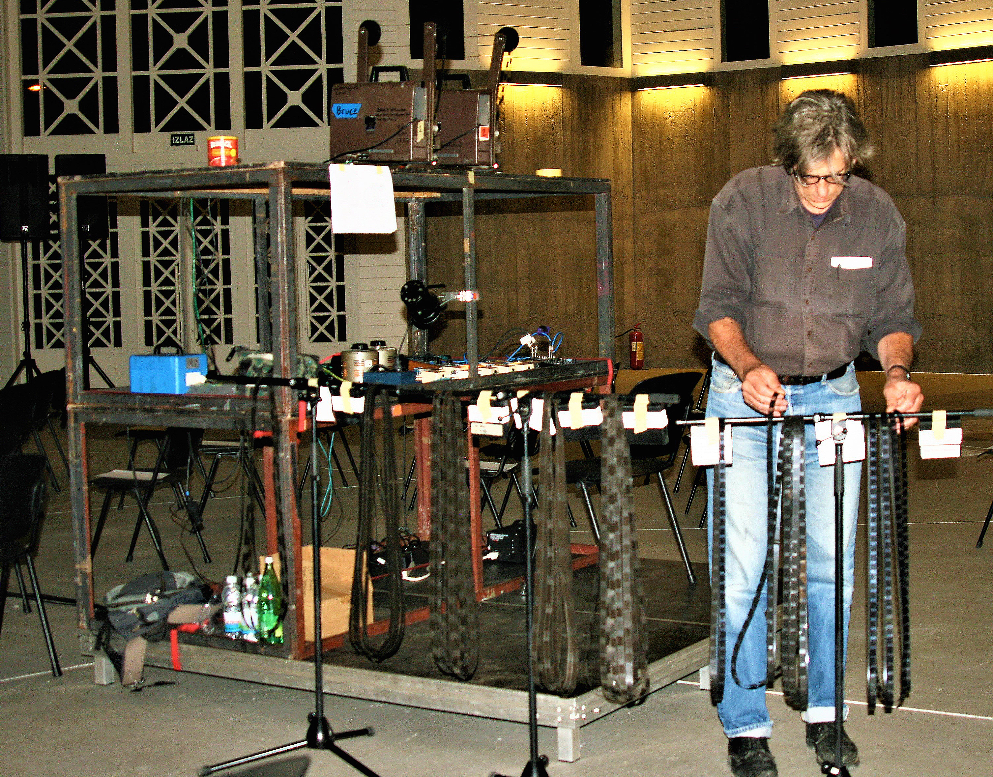

Image 3: Bruce McClure, Projector Setup. Photo: Robin Martin.

McClure adapts Cage’s idea to his practice, which makes creative misuse of a technology whose function has almost always been self-effacingly instrumental, to which end, as far as practicable, it should be neither seen nor heard. He is not the only filmmaker to have placed the projector in the auditorium (auditorium- ‘hearing place’, is peculiarly appropriate for his presentations, since sound often predominates) nor the only one to amplify its noises, but he has insisted on its primacy, both conceptually and materially, in a way few other filmmakers have. This is achieved in the way the filmstrip’s projection, which requires the presence of the projector, functions increasingly to refer and direct attention back to the latter, so that the filmstrip animates the projector, as it were, rather than the other way round. In some filmmaker’s work, such as Jürgen Reble’s performance work Alchemie (1991-), the projector’s motor noise is amplified, whereas McClure, like Sherwin and Rhodes, only uses the sounds generated by the filmstrip, so that there are precise structural-causal relationships between image and sound, yet which result, paradoxically, in a formally and experientially disjunctive relationship. This is used productively to focus on the two different technical and sensory modes.

McClure maintains that a filmstrip is at least not primary, even if it may be necessary, to there being a ‘movie’, or at least some kind of projected time-based experience. The small number of historic examples where film has been implicitly asserted as the primary component of a ‘film’, in which celluloid strips are exhibited as a translucent object sandwiched between sheets of Perspex or otherwise - Kubelka’s Arnulf Rainer, Paul Sharits’ various Frozen Film Frame works (1968-76)- does not disprove this assertion, since these exhibits are arguably not films, even though they are made of it. On the other hand, anything small enough to fit into a projector gate can be pulled through it to throw an image, or at least a something, as the filmmaker James Holcombe has demonstrated by using a projector to show hairs in the gate by literally placing them therein.7.
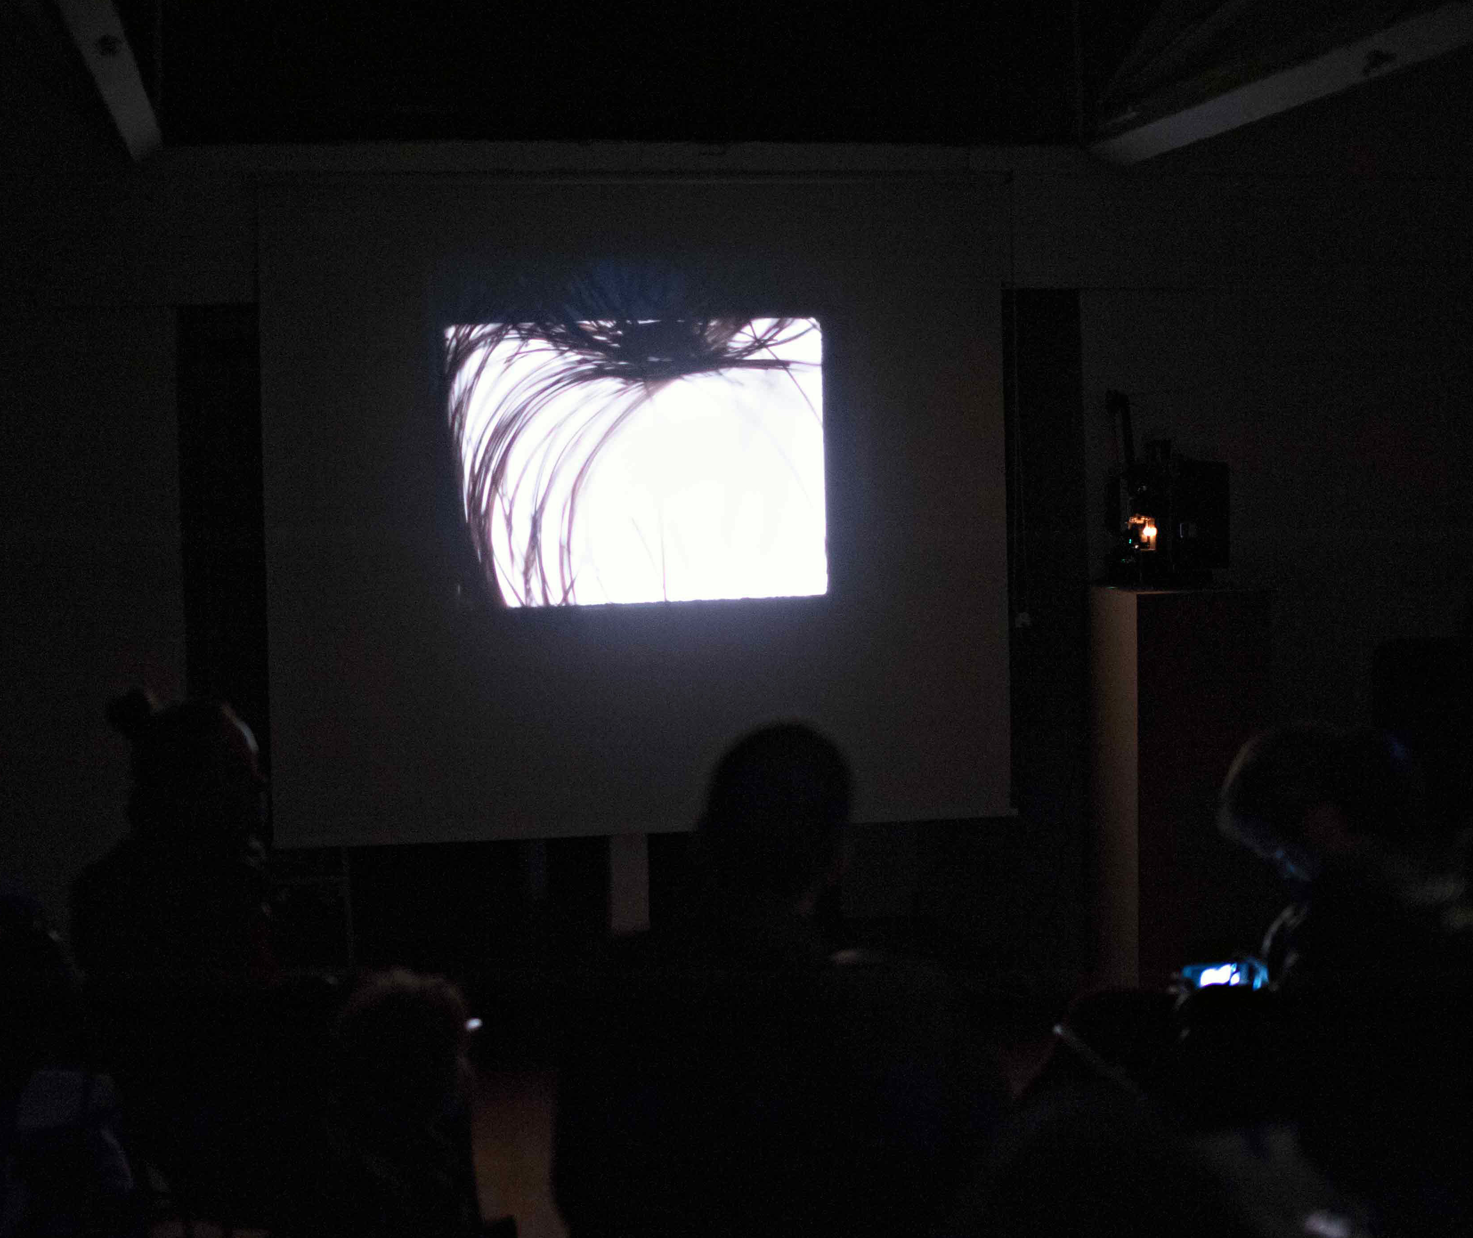
Image 4: James Holcombe: Hair in the Gate. Photo: James Holcombe.

Like Cycles 3 and Light Music, many of McClure’s projections are made for two projectors, whose images are usually shown side by side, in contrast to Sherwin’s superimpositions or the more environmentally engaged disposition of Rhodes’ machines, which in facing each other across the space, impel the audience to interact with the light beams. McClure’s films, by contrast, are made for a more or less conventional cinema arrangement, but they are otherwise quite unconventional, and indeed, in one of his characteristically allusive and densely metaphorical programme texts, he describes the work very much in terms of its total environmental effect:

‘The performances consist of between two and four binary systems: 16mm projectors, consisting of a primary lamp and exciter transponder interface threaded with film loops. Burst frequency, amplitude and duration, whether optical or auditory, are the signal parameters that range freely within an auditorium of neuronal excitability modulation provoked by patterned film strips. Projector headlights, the primary lamp and exciter bulb transfix the machine’s analogue, film, as potential road kill…Variable transformers wired in the lamp circuits are enlisted in the struggle. They permit the projectionist to alter luminance and the wavelength spectrum, breaking film’s stranglehold of fidelity and adding nuance to a subversion challenging filmic hegemony. Film’s reign as first in time and first in importance is overthrown by primitive impulses. 8.

The expression: ‘Film’s reign as first in time and first in importance is overthrown by primitive impulses’ refers, of course, to the projector’s claiming primary position over the filmstrip, but also to its disruptive function, its light pulses that threaten to obliterate the image and its smooth passage from projector to screen.

Here one sees how the ‘misuse’ of projectors is extended to language: McClure applies the same disruptive principle to all aspects of his project: in his writing the abrupt shifts between anthropomorphic, sporting and political metaphors, to scientific descriptions, are both suggestive and disconcerting, forcing the reader to reconsider the conventional sense that these categories must be mutually exclusive. The idea of film as ‘road kill’ engages with notions of animation and re-animation: the quickening of the dead, but also its killing off, since in much of his work the filmstrip per se, and its image-bearing function, is minimised, although its sound generating function is enormously enhanced and augmented.

Besides the fact that each frame must ‘die’ in order to give way to its successor, McClure’s loops often contain several black frames, as in the two projector work THIS HARMONIC CONDENSER ENGENIUM (2011), in which triple flashes are interspersed with pauses of a second or so of black.

Also important to note is the consideration of the work as environmental. It is fashionable to talk about immersiveness, but few artists or filmmakers really address with any level of precision the relationship between technology, performer, environment, experience and effect in this way, in terms, almost, of molecular interactions. The immersiveness comes almost entirely from the very loud sound –the projection itself is often contrastingly small and dim.

McClure makes black and white loops by bleaching selected frames in a sequence. The two, or sometimes three projectors, each carry one or two loops. Rheostats have been wired-in so that the image brightness can be varied. The sound, generated directly from the image as an optical track, is fed through a set of guitar effects pedals.
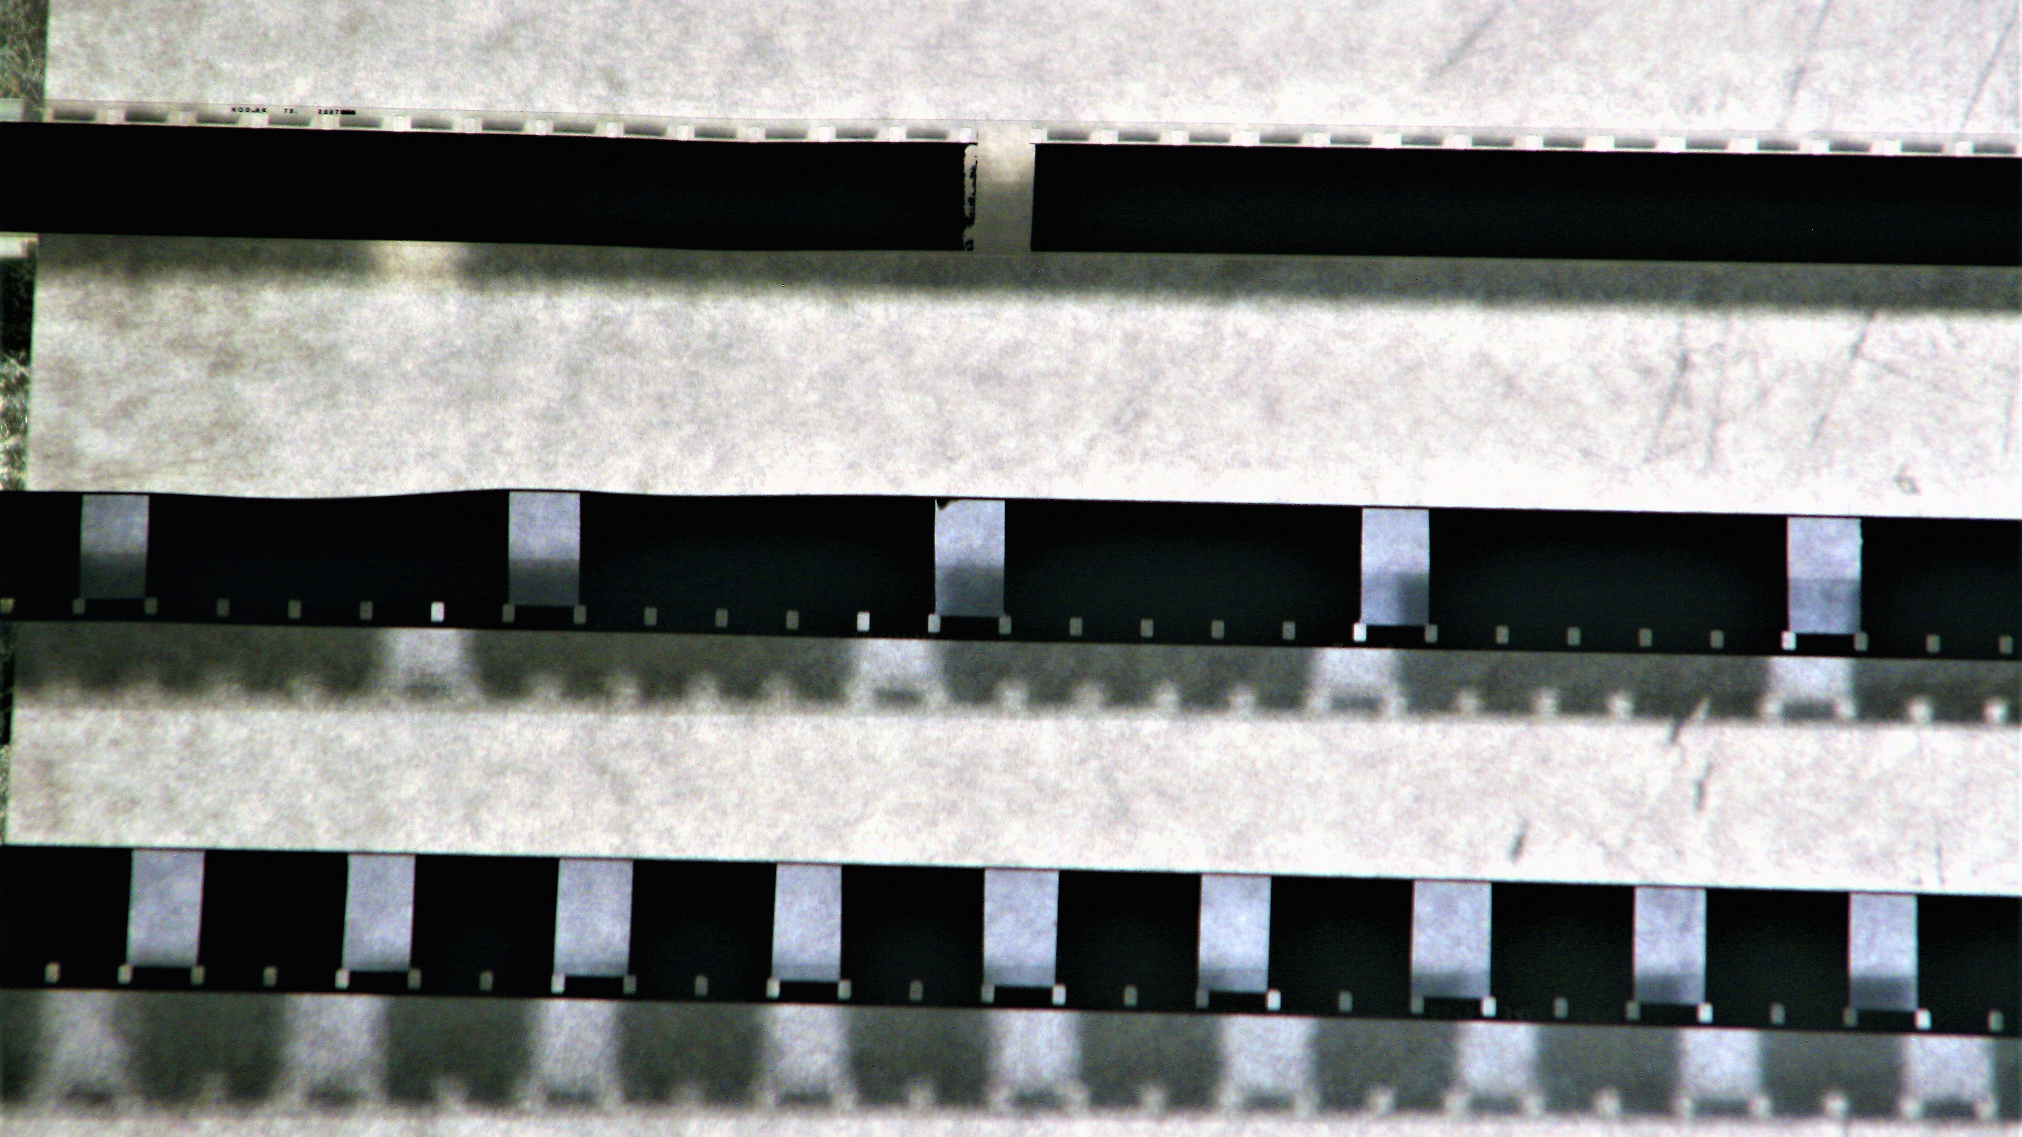
Image 5: Bruce McClure: filmstrips. Photo: Robin Martin.
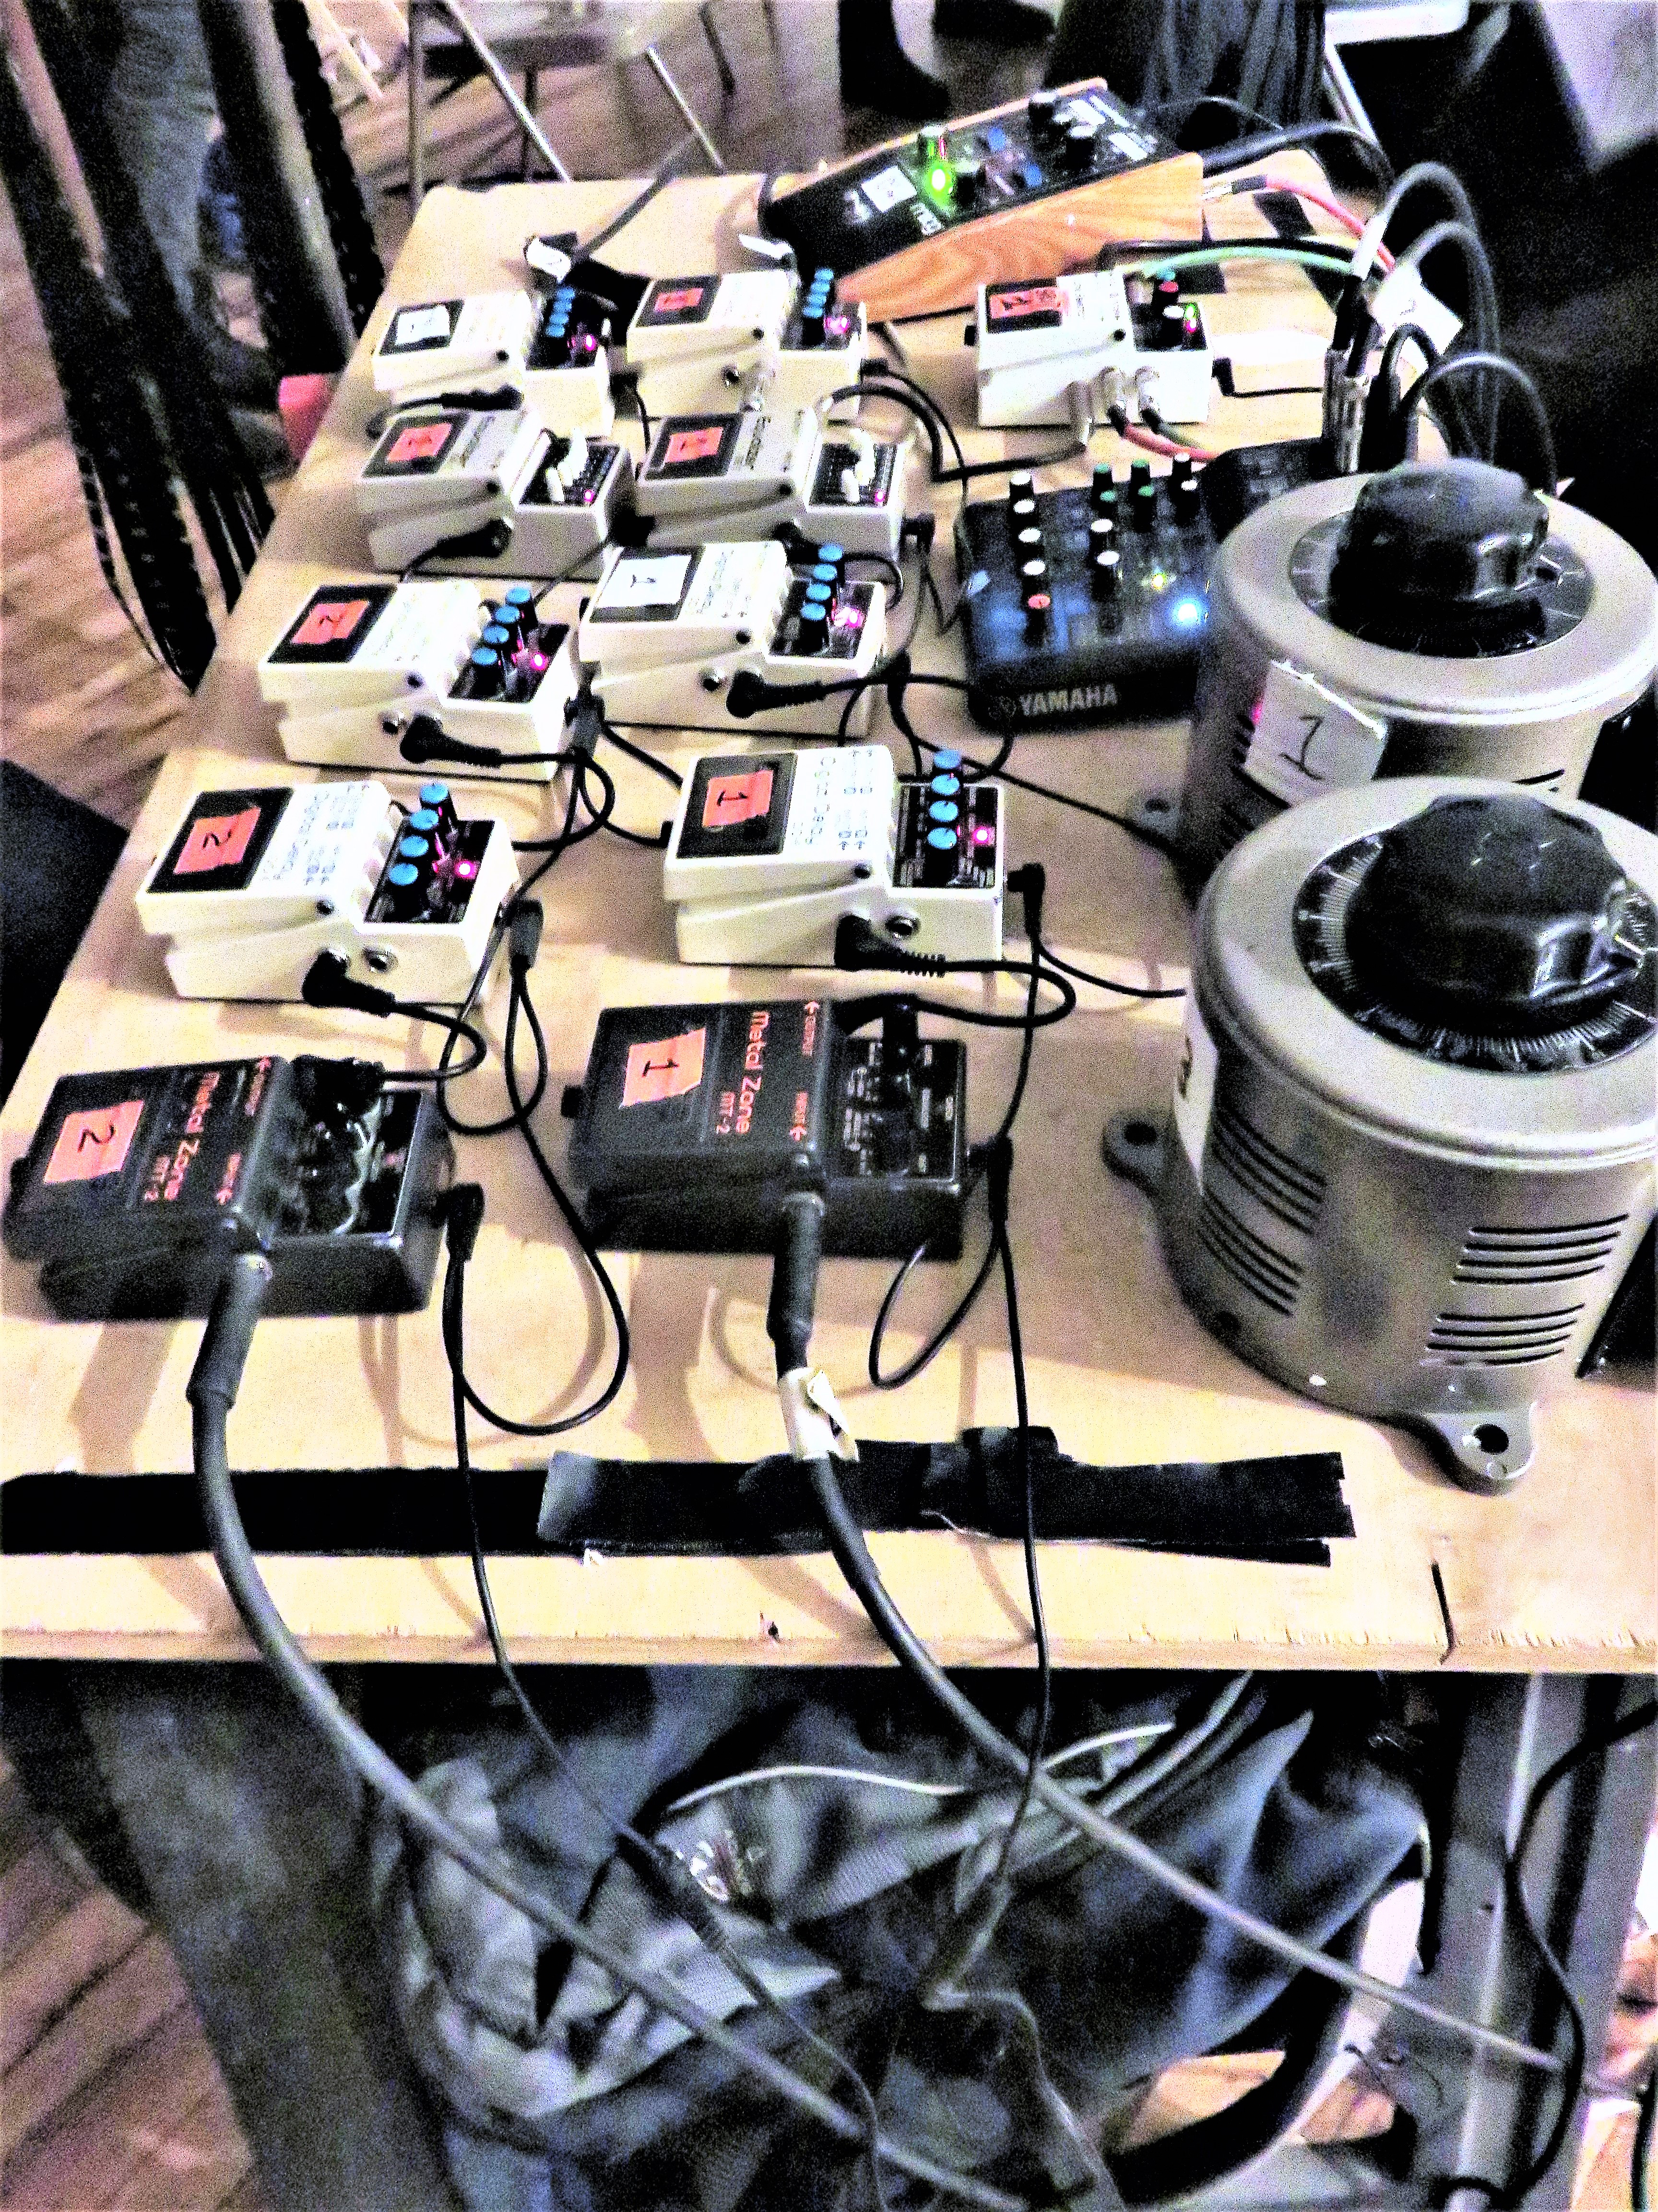
Image 6: Bruce McClure, Effects pedals. Photo Robin Martin.

Over the years, sound has come to dominate. The rectangles of projected light have got progressively smaller, while the sound has increased in intensity, so much so that ear-plugs are sometimes distributed to the audience. The filmstrips are vestigial and disposable: insofar as they are made from lengths of black spacing, a resin-coated material manufactured for the purposes of negative-cutting, they can be re-made if they wear out. They are a small but necessary activator, rather than conventional image bearer, something whose presence has been minimised to the point where its quasi-redundancy can be recognised by the viewer. As McClure himself has said:
My standard replies to the filmy things are something like this:
"I don't make films KODAK does."
"For me, my interest is the limit of film as x approaches 0."
Some kind of corollary for this would be "I have an asymptotic
relation to film - its a symptom." 9

The asymptotic ambition, to approach (but not ever to quite reach) the point at infinity where film’s normal function approaches 0, arguably formulates the ambition to minimize the importance of the filmstrip while acknowledging that it must not be eliminated entirely. This point is taken up below.

The patterned filmstrips serve to re-present film as flicker, to bring back the effect of the shutter from the early years of cinema when it was a single bladed device running at around 16fps. The alternation of black and white frames generates a 12fps effect, below critical flicker fusion threshold, though this partly also depends on other factors such as projector and environmental light levels. McClure is aware of the fact that the projected rectangles create a kind of limited Droste Effect or mise-en-abyme, in that the frame’s rectangle projects what could be thought of as an ‘image’ of a rectangle, though it’s not an image of anything in the normal sense, but simply a something where an image –a representation in the case of film, typically- would normally appear, and this serves McClure’s purpose of asserting the primacy of projection per se as opposed to what is projected. Paul Sharits Raygun Virus (1966) consists of sequences of coloured frames, some of which appear as plain colour-fields, but some of which appear as filmed surfaces, in conformity with his view that in film the: ‘phenomenology of the system includes ‘recording’ as a physical fact’. In other words, Sharits’ film, for all is surface abstraction, explicitly shows those abstract colour frames to be photographic images of coloured surfaces10. Even the white frames in Conrad’s The Flicker were made using a camera with the lens removed, so that they are indexical at least, because recordings of something, even if only a light source. McClure’s flashing rectangles of light, however, cannot be representational or even visibly indexical, since the process by which they were made cannot be inferred from the trace of that process.
McClure’s frames are presentational rather than representational. They simulate the opening and closing of the shutter, effectively slowing down the flicker rate until it is perceptible as such, and often beyond this point, to around two pulses or less per second. This effect roughly approximates that of literally slowing down a projector to 12fps, except that in a projector really running at that speed the inter-frame moments, when the shutter is closed between frames appearing, would be more evident.

The bleaching of the frames is achieved by the manual process of attaching splicing tape to either side of the frame to be bleached. The almost impossible precision required to align the edge of the tape with the frame line results in variations in the degree of accuracy with which the black coating is removed. Errors, caused by the misalignment of the tape edges, result in erratic unbleached wedge-shaped slivers of black at the top and bottom of the frame. These generate dancing zigzag lines on projection, and this effect distinguishes the sequences from those of Kubelka or Conrad. To this extent the film in the projector is essential and irreducible for visual as well as sonic reasons. An empty projector would be less than what an unpainted canvas was for Clement Greenberg, who said that ‘a stretched or tacked-up canvas already exists as a picture –though not necessarily as a successful one’ 11. The filmstrip for McClure is a necessary condition for the work. Were it absent the projector would still be a film projector but there would be no projected image / rectangle, and no soundtrack: noise, yes, but not a soundtrack in the filmic sense. The questions arising from what film projections are and can be, the relationship between the various parts in the technology, the questions around (re) presentation versus simulation etc., would be circumvented, resulting in a lack of conceptual friction and the reduction of the work to a purely technological demonstration or a presentation of moving graphics. Besides all this the filmstrip is essential to generate the optical soundtrack, whose relationship with the image, or what there is of it, is also important in calling the sound-image relationship into question. Actually it would be possible to project the loops with the lamp turned off, so that just the sound was generated, though this would over-reduce the presence of the filmstrip, rendering its image, if not the strip itself, invisible. It’s important for the work that it shares with conventional film certain features and mechanisms, upon which it is dependent for its critical distance therefrom.
By emphasizing the discrepancy between the film’s projected light and the overwhelming sonic field generated from it, McClure insists on the distinctiveness and haphazardly related main elements of film, sound and image. This is not to say that his work engages at all explicitly with issues of Cinematic realism, simply that, in its mobilisation of shared, mostly technological features, it stimulates some reflection on what are the necessary and sufficient conditions for something to count as a film or a ‘cinematic’ experience.
The invention of sync-sound was the first step on the path to simulation, a megalomaniacal quest subsequently conducted via super wide-screen formats, surround-sound, IMAX and the kind of simulated ride and 360° projections available at theme parks. McClure takes us back to basics, at least as far as 1927 anyway, by effectively prising apart the sound image synthesis (and ironically of course the presence of film projections in theme parks takes us even further back, to the typical context for film screenings before dedicated cinemas were developed in the early 1900s). In contrast to Sherwin’s optical sound works, where the causal image-sound relationship is integrated and mutual, McClure effectively disconnects the two, since it’s impossible to see how the image can be seen to be generating the sound because of its out of focus, vestigial character.

Inside the projector is another much smaller projector, the sound Exciter Lamp, which projects the image of the soundtrack onto a photo-electric cell, which converts the black-white alternations of light into a fluctuating voltage that goes via the amplifier and guitar effects pedals to the loudspeaker. There is a relationship between this function, a small thing generating a very big –loud- thing and the way the dim image refers back to the projector as generator of everything. All this together reinforces McClure’s conception of projection, and, a fortiori, the projector, as primary. The sound is typically an insistent, heavy, almost ponderous metallic pulsing, which clangs and throbs with a surprisingly wide range of frequencies, including higher tones that one would not somehow expect, although the guitar effects pedals certainly play a key role in complicating and thickening the textures and qualities of the sounds. The pulses shift in and out of phase regularly, disrupting the basic rhythm to generate chaotic periods before shifting into sync with each other.

This Harmonic Condensor Enginium (2011) is a two-projector work for bi-packed loops -two loops in each projector- as follows: ‘Projector 1 – Bi-packed. A common loop patterned with one base to three frames of emulsion. (c = 200 frames) with a negative print with one emulsion removed (c = 199 frames). At the cut there is an interval of 6 base frames. Projector 2 – Bi-packed. A common loop patterned with one base to three frames of emulsion. (c = 200 frames) with a negative print with one base removed (c = 199 frames). At the cut there is an interval of 2 base frames’ (McClure’s notes).
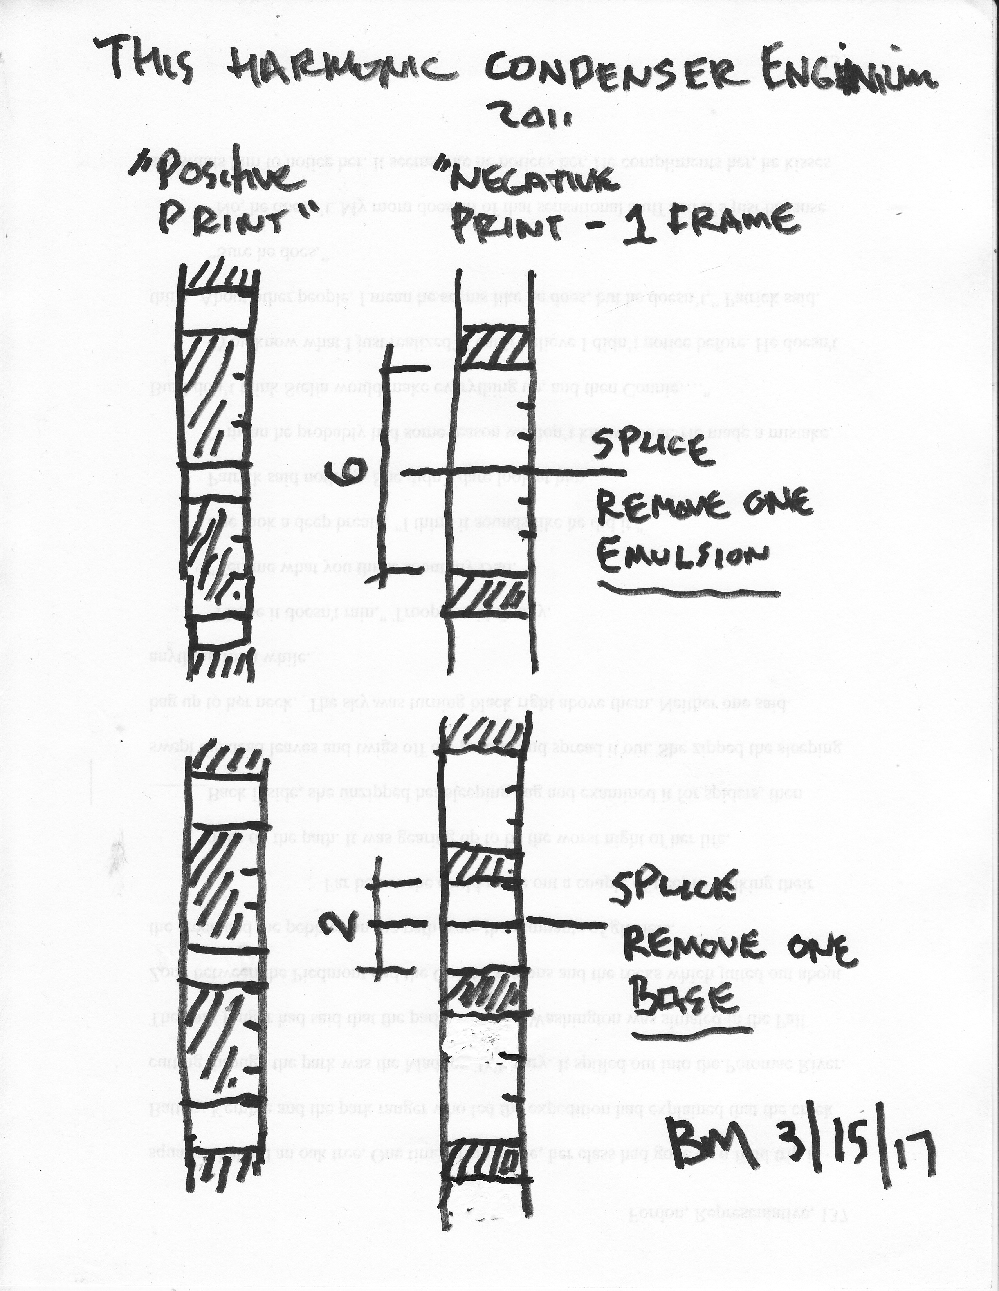
Image 7: This Harmonic Condenser Enginium. Diagramme: Bruce McClure.

The one frame difference between the loops means that at every rotation the juxtaposition of frames shifts by one, resulting in a pattern of black and white frames that is repetitive but extended by the in-built permutations. Furthermore, because film projectors all run at slightly different speeds, the interplay of the two adjacent projections also shifts in and out of sync, resulting in a continuous variation in patterns of juxtaposition, in a similar way to Sherwin’s Cycles 3. The degree to which the image is defocused also affects the perception of these patterns. When the frame edges are sharp there is a stronger sense of geometric flickering ‘image’, but as they go out of focus a softer more general and dispersed strobe effect takes over, especially when the brightness is reduced.

In many of McClure’s projections focus is out in the conventional sense, indeed there is no definitive point of focus as there is where there’s an image to sharpen: in keeping with his prioritisation of projection per se, the degree of focus becomes unimportant in this respect, but not in others. This, not withstanding the zigzag lines whose effects are still apparent when the image is out of focus to some degree. Extreme defocussing further diminishes the sense that one is watching a projected filmstrip, because the rectangle loses its shape and the resulting uneven distribution of light compounds this, combined with the aforementioned dimness and smallness of the image. All possible aspects of the projected rectangle are reduced. It is only the presence of the projectors in the space that reminds us of what is generating the light-play on the screen, pushing the experience towards the asymptotic trajectory discussed above.

This leads on to some other works where focus is more important. In some of these, brass plates are inserted into the projectors’ apertures to modify the standard aperture. In Unnamed Complement (2007), each of three projectors has a different brass plate inserted into the gate; one vertical, which blocks the light from all but the vertical edges, one horizontal similar to the vertical and one ‘open’, which unblocks but modifies the existing rectangle:

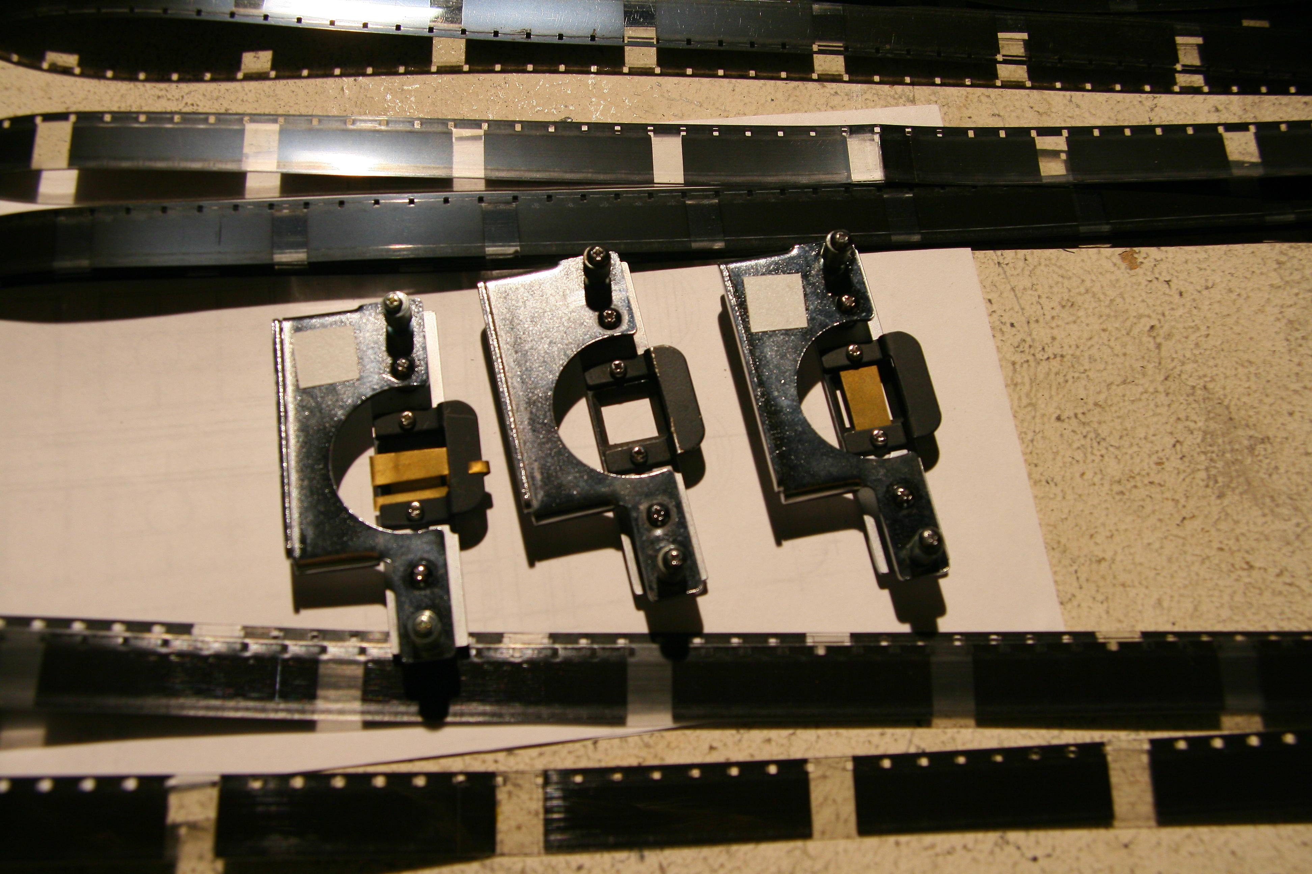

Image 8: Filmstrips and projector gate inserts. Photo: Bruce McClure.

Focus can be pulled progressively through the gate, the metal plate and the filmstrip. In a film projection, when the image is in focus, the framing edges are not, because the projector gate, the rectangular cut-out within which the individual pictures are briefly held while light is shone through them onto the screen for 1/50th of a second, is in a different plane to the celluloid strip relative to the lens. If the edges of the metal plate are brought into focus then the image will be out, and one has more the sense of light shining through an aperture, as opposed to seeing a projected image-shape (McClure has stated that he’s not interested in images projected onto surfaces: ‘it isn't about images as images. I suppose I am more interested in what happens where the meeting is’ 12). The screens can be superimposed to generate composite forms that at the same time partially obliterate each other, specifically when the open aperture is superimposed, since the light shines onto the dark areas masked by the other two plates, so that contrast is reduced, when bleached frames coincide. The open plate is the reverse –negative- of the other two since it opens the space blocked by the other two and vice versa: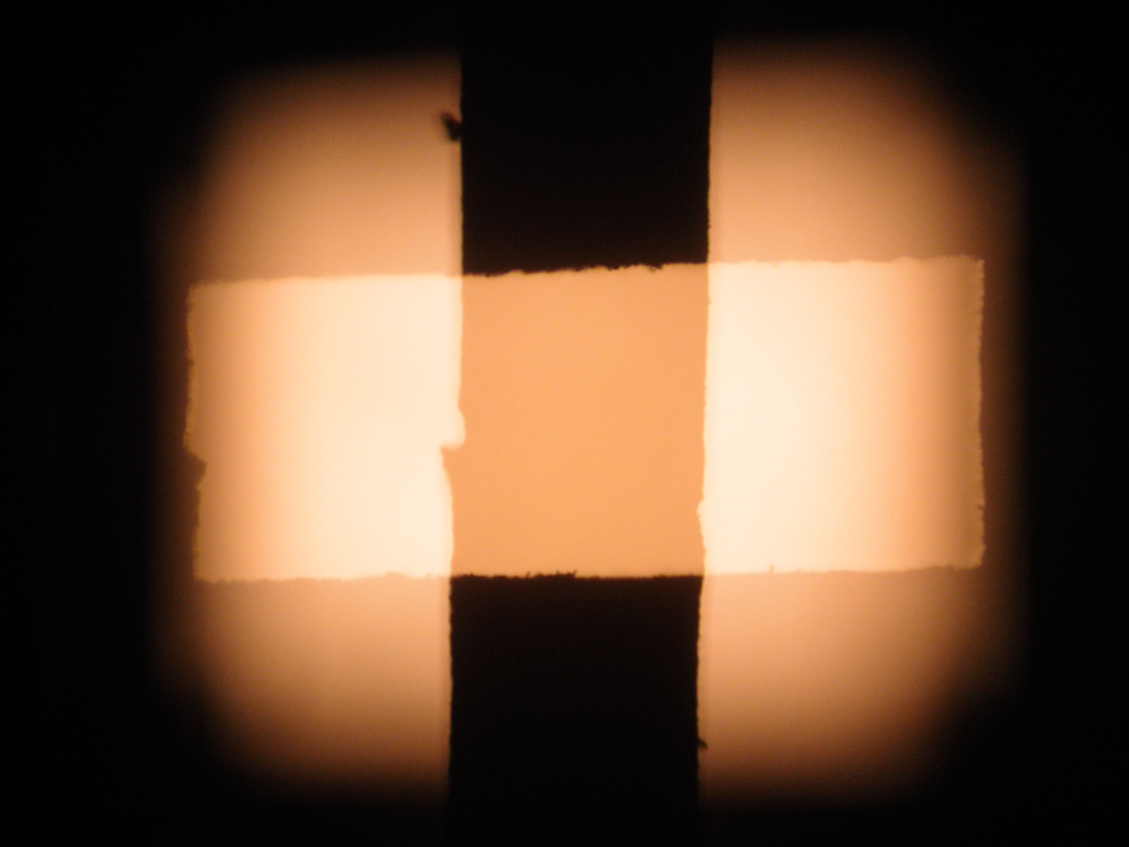.
Image 9 and 10: Unnamed Complement: Superimposed and single modified gate projections. Photos: Robin Martin.

In this way the projector gate, which is essential to the projection of anything at all, is itself modified in relation to its existing edges, so that conceptually and visually a kind of nothing becomes subject to modifications that are formal, implying a something. Although the plates in the projector form an image on the screen, it is not, in conformity with the aforementioned work, a projected image, certainly not in the sense of a graphically marked –drawn /scratched- or photographically recorded translucent thing held on a transparent medium through which light is shone. The film loops, similarly, do not so much project an image as allow the passage of light. (One could argue about whether an imageless strip of clear celluloid bears an image, since if nothing else, light is refracted as it passes through the celluloid, emulsion and binder layers, even if their effect is hard to measure without a ‘control’ for comparison. This fact is shared with all film, regardless of how much of a photographic image there is).

In Unnamed Complement focus can be pulled on each projector creating conjunctions of in and out-of-focus shapes that change in size and shape according to the degree of lack of focus. Thus it can be seen how a very complex experience is generated permutatively from a combinatory method, though ‘permutation’ implies a more systematic working-through than is the case in performance. The process can be said to be additive, though addition can also lead to obliteration because of the simple fact that superimposed light projections eventually cancel one another out.

Most of McClure’s works push at the limits of what a movie, or movie experience (cinema) can be, what are its necessary and sufficient conditions. Most of the essential parts required for the conventional production and presentation of a movie –camera, lenses, sound recorder, negative, development, print- have been subtracted until just the filmstrip and the projector remain, but it is the projector that is the sine qua non. Sound, the technological late-comer to film, is prioritised. This distinguishes his work from the aforementioned Frozen Frame works but also from video projection, where the projector is self-effacing and in which the image is generated by the projector through the electrical stimulation of pixels, as opposed to being carried fully formed on a discrete medium. Although the filmstrip’s status is minimised, in an image-carrying sense its importance is reaffirmed in other ways.

In his essay Transparencies on Film, Adorno argues: ‘Even where film dissolves and modifies its objects as much as it can, the disintegration is never complete. Consequently, it does not permit absolute construction: its elements, however abstract, always retain something representational; they are never purely aesthetic values 13. Adorno was talking about the Cinema, in which the technology’s intrinsic, inescapable realism condemns it to record, thus denying the possibility of true artistic construction / intervention. (Adorno argued that montage could achieve this through film’s aspiring to the condition of writing). In McClure’s work constructive intervention does take place, but as a form of reductive negation, not at all with the aim of developing the kind of finer-grained artistic discourse that could allow film to overcome its slavish relationship to the recording process that denies it the status of art according to Adorno. Rather the construction consists in a reconfiguration of film’s technological parts in order to stimulate a reflection on the relationship between such art’s technology, medium and form. The work situates itself as far from cinema as it can without becoming something else entirely, and addresses the way that the peculiarities of the technology are essential in understanding that something is film or not. Without this distant critical relationship to cinema, the work would simply exist as a kind of audio-visual experience unrelated to it, where it would risk becoming an empty display of graphic forms and noise, or another kind of son et lumière, a stripped-out version of the work mentioned earlier.
It’s tempting to criticize McClure’s oeuvre for being too ‘technology-driven’, too dependent for its aesthetic power and effects on the technical power of the apparatus. However, in modifying and augmenting the conventional technology of cinema, and by drastically shifting the balance of resources –sound and its dispersal, image, rhythm, the technology-as-medium is effectively re-tailored, so that the distinction between medium and the technology supporting it, which underpins the very idea of ‘technical media’ -media art- is partially eroded, leading to a necessary re-evaluation of what the two terms mean in relation to each other. The reconfiguration that McClure undertakes can be seen as a way of adapting technology in the service of new aesthetic possibilities, in a similar way to that by which a painter might use a modified brush to transform the texture of a painting.

- Dean’s campaign to ‘save’ film took her to UNESCO among other places. The trip was made into a story, which was broadcast on BBC Radio 4 on Thursday 17th April 2014. Bains Argentiques, an annual meeting of artist-run film laboratories, was held in Nantes, July 4-9th, 2016. On the commercial front, Kodak have revived film production and in 2017 announced the re-introduction of Ektachrome Super 8 film and a new high-end Super 8 camera. They have also taken over two existing labs in the UK, iDailies in Park Royal, London and Cinelab in Slough, west of London.
- Notable examples include Malcolm LeGrice’s six-projector films After Matrix and After Leonardo (1973), both of which are performance pieces, but these are exceptional. Most expanded works used between one and three projectors, such as William Raban’s Diagonal (1973) and several of Gill Eatherley’s films. Although Eatherley’s work, as well as that of Annabel Nicolson and Marilyn Halford, often involved performance, these examples were all of a finite duration and much more structured than most of their contemporary counterparts.
- Cycles and numerous other such works are gathered on the DVD: Guy Sherwin Optical Sound Films 1971-2007, published by LUX in 2008.
- Bruce McClure, 2014: Know they Instrument, Atelier Impopulaire, p 14.
- Cage, John, 1958, ‘The Future of Music: Credo’, in Silence, Wesleyan University Press, pp 3-7.
- Cage, ibid, p3.
- James Holcombe’s Hair in the Gate, was first performed in October 2013 at the Living Film screening at No.w.here, London. Holcombe animates the hair live, hence another form of animation, that also links back to the pre-history of cinema.

- Bruce McClure 2011: Sinossi Completa, unpublished text.

- Email to the author, 05.06.2011.

- Paul Sharits, Words per Page’, After Image 4, 1972, p 29.

- Clement Greenberg: ‘After Abstract Expressionism’ (1962), Collected Essays vol. 4, ed. John O’Brian (Chicago: University of Chicago, 1993), pp 131 – 132.

- Email to the author, 18.04.2017.

- Adorno, Transparencies on Film, 1966, page 4, available at: https://www.scribd.com/document/102185546/Adorno-Transparencies-on-Film

