Craft Hub EU Conference
Theme 1: Exploring Craft Heritage.
Title: Creative impulse of craft curator: Craft practice as a continuous journey that mutates and transcends to adapt to the needs of each society.

Loucia Manopoulou, MA, MRes, PhD,
Curator-researcher
University for the Creative Arts

This paper deepens the understanding of the ontology of craft curation and the reason for being. I explore curation as research, reflecting on Peter Bjerregaard’s concept of exhibition as research. Bjerregaard argues that exhibitions require to move away from the notion of knowledge, as based primarily in text, and turn knowledge into text’s material and spatial arrangement. The arrangement of the exhibition is linked with the stage setup, the mise-en-scène. This paper approaches mise-en-scène curatorial process, as has been denoted by textiles scholar Professor Lesley Millar, and explores new frameworks interpreting craft and curatorial models that shift focus towards the agency of objects, thereby exposing alternate models of relationality. I will evidence that by using exhibition as research and by considering the character of the objects (process of making and material) as well as the mise-en-scène, the exhibition serves as a form of contextualisation for crafts.

The paper emphasises new dynamics by challenging the traditional role of the craft curator and compares it to an auteur, as seen in film practice. I will discuss mise-en-scène as the site where the craft or the viewer performs. The paper draws from Glenn Adamson in considering crafts not as ‘a fixed category,’ but rather as ‘an active, relational concept,’ embodied most powerfully in skill, ‘a process’ that ‘only exists in motion’ (Adamson, 2007:3-4).

This presentation examines two curatorial projects: Makers’ Tale at Salisbury Arts Centre (2020-2021) and Hidden History at South Hill Park, Bracknell (2020). These projects share the commonality of revealing human connections that exist in objects, echoing Adamson’s: ‘Every object represents a potential social connection. By better understanding the tangible things in our lives, we better understand our fellow humans’ (Adamson, 2018:8).

Both projects are inspired by craft within buildings, considering that buildings act as time capsules and the craft within them are still located as the practitioners intended. The buildings are not separate from their environment or seen as isolated single objects but rather have resonance that survives time. One of the doctrines offered by this paper is that craft practice is a continuous journey that mutates and transcends to adapt to the needs of each society.

In particular, Makers’ Tale was informed by the octocentenary anniversary of Salisbury Cathedral, marking the laying of the foundation stones on 28 April 1220, an act of strength, and craftsmanship. The act of skills sharing is manifested within the Cathedral’s works department where masters have passed on their knowledge undisrupted since 1220.
Makers’ Tale highlighted the persistence of craft knowledge through textiles and ceramics, as well as with a new music composition titled Plangency, specifically commissioned for the project.

Hidden Histories was an installation of miniature vessels by textiles artist Alison Baxter, inspired by the overlooked stories of the women inhabitants at South Hill Park, a historic Victorian mansion in Bracknell, Berkshire.
This project proposed a different narrative about South Hill Park’s women inhabitants through contemporary textiles, reflecting on the creative medium’s unique history, closely intertwined with social, cultural, and political values.

My paper will demonstrate that dialogue has a resonance into developing new narratives. Both projects employed this approach to develop narratives and commentary between the traditional, contemporary practice and the exhibition-making space resulting in an on-going exchange.
Through the development of these new practices, the curator’s practice is expanded, where new knowledge together with skills are acquired. A curatorial craft approach emphasised human skills, including a mastery of technique and the ability to use multiple skills to control the making process from start to finish. Moreover, it required embodied knowledge, i.e. knowledge not only from conceptual skills, but also from practical, tacit and contextual knowledge.

The analysis of these exhibitions demonstrates how contemporary craft curation makes room for pluralistic practices that combine and cross, formerly distinct borders, disciplines, materials, techniques, and histories. Considering Makers’ Tale and Hidden Histories process of the curatorial, demonstrates two key points, the prominence of craft to people and organisations and the way this relationship is articulated through the curatorial. Moreover, the impact of craft curatorial practice in the audiences’ experience and engagement. (676 words)

Key words:
Textiles, ceramics, craft curatorial, auteur, mise-en-scène, historic building, narrative, storytelling, heritage.

References
Adamson, G. (2007). Thinking through Craft. Berg Publishers
Adamson, G. (2018). Fewer Better Things: The Hidden Wisdom of Objects. Bloomsbury
Bjerregaard, P. (2020) Exhibitions as Research: Experimental Methods in Museums. Oxon: Routledge
Millar, L. (2011). Lost in Lace: The Exhibition. [Exhibition catalogue]. Birmingham Museums and Art Gallery
South Hill Park (2020) Hidden Histories [Exhibition] Bracknell: South Hill Park Arts Centre
Wiltshire Creative (2021) Makers’ Tale [Exhibition] Salisbury: Salisbury Arts Centre

Photographs
Makers’ Tale
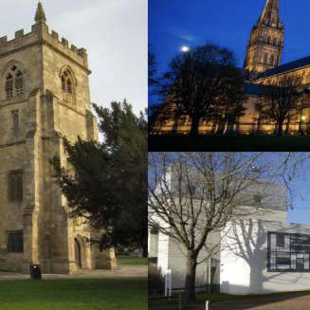
Makers’ Tale (2021) research project brought together Salisbury Arts Centre, Salisbury Cathedral and the University for the Creative Arts.

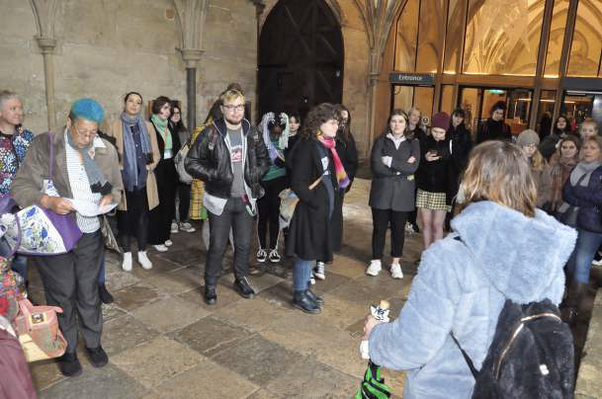
Makers’ Tale (2021) Students from the school of Craft and Design visited the Salisbury Cathedral on Tuesday 14 January 2020. Photo courtesy of Mirka Golden-Hann.

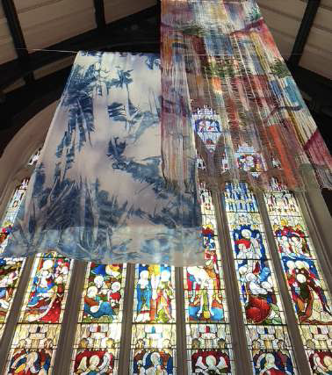
Makers’ Tale (2021) View of the installation of textile maker Charlotte Bull. Photo possession of the author.

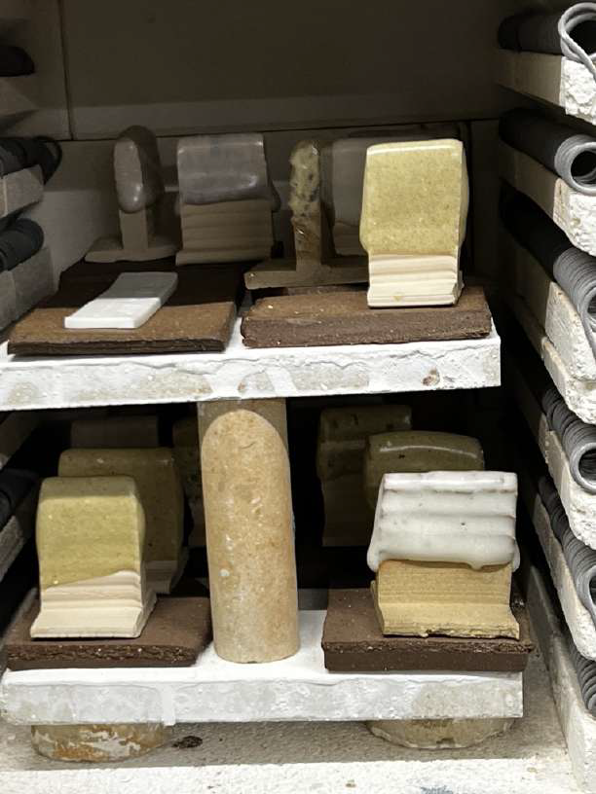
Makers’ Tale (2021). Ceramicist Michelle Shields Glaze experiments using the dust – waste – from Salisbury Cathedral Stonemasonry Works Yard. The material works as a flux in glazes. Photo possession of the author

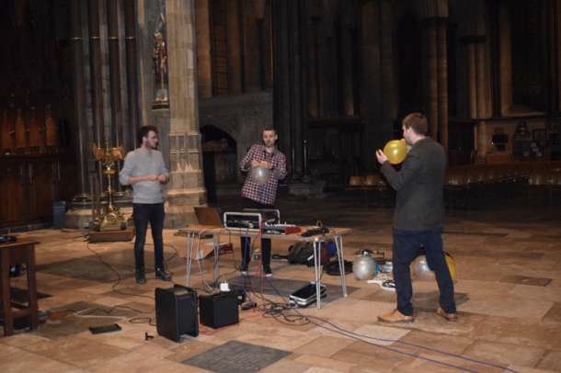
Makers’ Tale (2021). The composer Dr Harry Whalley with a team from the UCA Music Composition and Technology course visit the Salisbury Cathedral to collect the sounds of the building for Plangency music piece. Photo courtesy of Dr Harry Whalley.

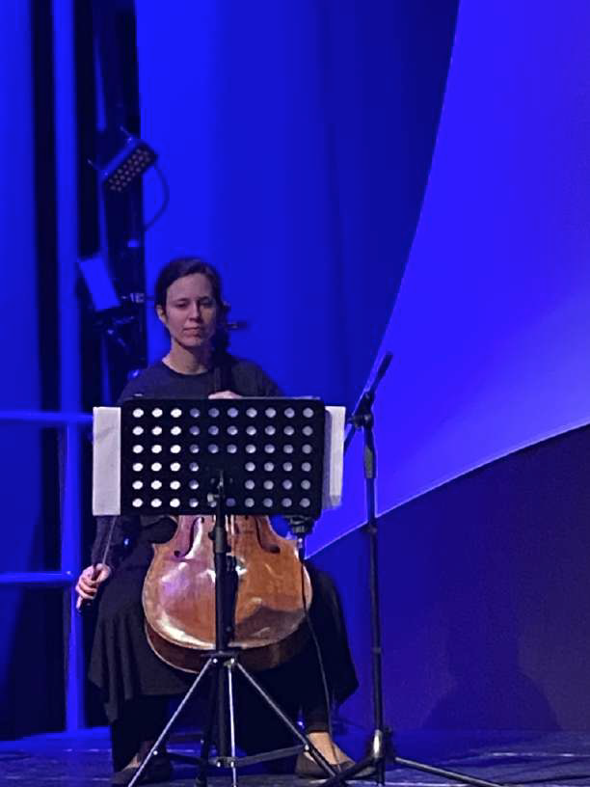

Makers’ Tale (2021). Plangency Anna Menzies cello performance at the preview evening, 22 September 2021, Salisbury Arts Centre. Photo possession of the author.
Hidden Histories
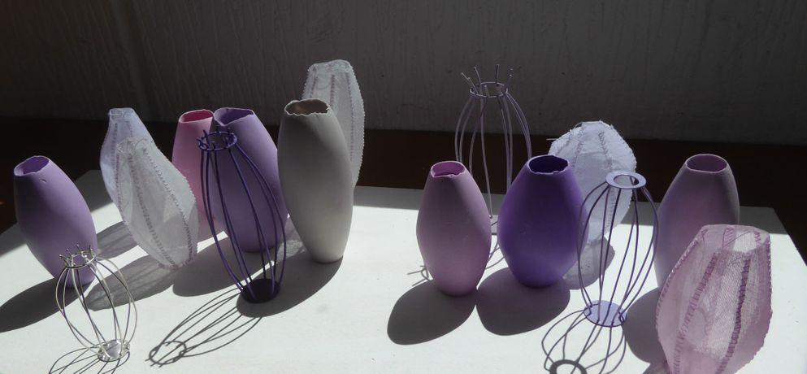
Hidden Histories (2020) Overview of the miniature vessels. Photo courtesy of Alison Baxter.
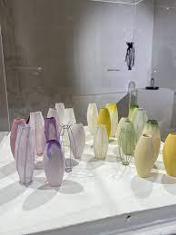
Hidden Histories (2020) Installation view. Photo possession of the author.

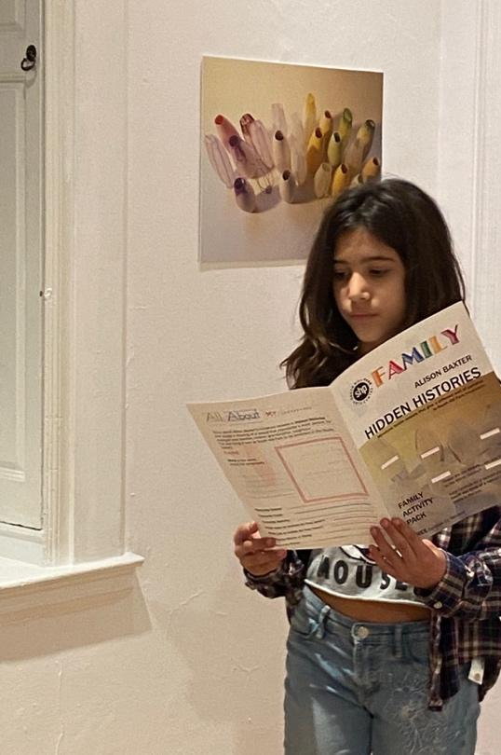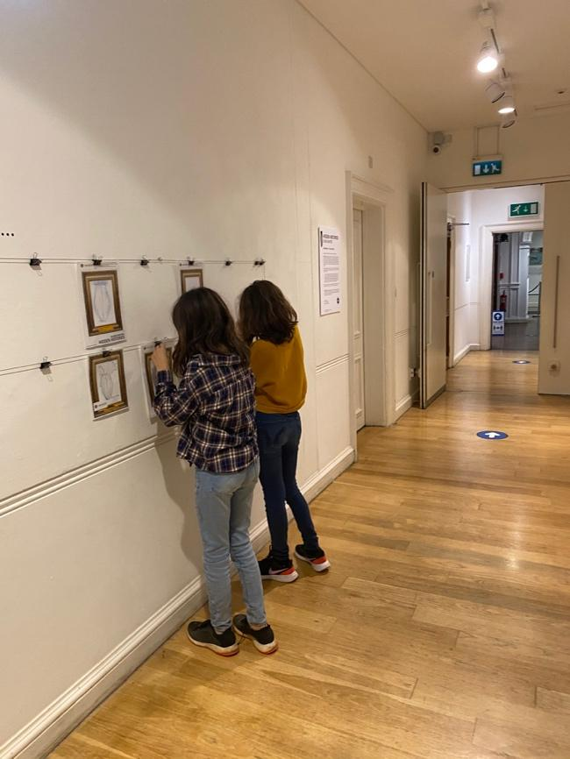
Hidden Histories (2021) Captions from exhibition preview event, 10 December 2020 Visitors were invited to be active and reflect on the miniature vessels through drawing and writing, which accumulated across the Studio gallery wall.. Photo possession of the author.

