Article for City: Analysis of Urban Trends, Culture, Theory, Policy, Action

'"This is a Private Public Park": Encountering Architectures of Spectacle in London's Olympic Park'

Abstract
Since the end of the 2012 Olympic Games, London’s residents and tourists have been awaiting the spectacular redevelopment of the former Olympic venue into the Queen Elizabeth Olympic Park (QEOP), which comprises the city’s ‘newest park’. As the most visible legacy of the Games, it has become a key test case for demonstrating the public interest of London 2012 and its legacy. In this article we engage with the park in the first year after its opening, when it became the site of a range of public cultural projects commissioned by the London Legacy Development Corporation, which manages post-Olympic redevelopment. Through observant participation in one such commission, a six-month mobile residency on site, we gained insights into the tensions emerging from claims to publicness in the making of this new ‘private-public park’, further explored through interviews and visual methods. We propose to term architectures of spectacle to analyse the logic expressed in the design and management of the park and discuss its articulation across three dimensions: (in)visibility, micro-regulation and disorientation. We critically analyse each of these elements and their relationship to competing claims of publicness and the ‘security legacy’ of the Games, raising wider questions about the spectacular public performance of the post-Olympic legacy.

Key Words: private-public space, London 2012 Olympics, public art, urban design, architecture, spectacle, surveillance, observant participation

Introduction
Olympic Games worldwide have been heralded as the epitome of global spectacle (Shin, 2012; Wolff and Gibbons, 2012). As transnational machines for urban growth, they usher in sophisticated forms of spectacular urbanism and have become, over the years, “an increasingly important driver in the creation of new leisure and consumption space” (Surborg et al. 2008: 342) in cities across the world. The London 2012 Olympic Games have not been an exception. Urban scholars have studied its exceptionality in relation to a growing militarisation of space (Graham, 2012) and to multiple dynamics of displacement and exclusion (Kennelly and Watt, 2012; Watt, 2013), linked to longer histories of urban development (Davis and Thornley, 2010; Poynter, 2009). While much critical attention has been devoted to the periods preceding and concurrent with the spectacle itself, the opening of the main Olympic site in East London in April 2014, was met with a relatively muted response. The area, rebranded Queen Elizabeth Olympic Park (QEOP), had been physically and symbolically fenced off view for seven years (Dorley-Brown, 2012) and its opening as an entirely new redesigned public space offered an experience of spectacular disorientation. In this article, we aim to engage with the post-Olympic spectacle through an analysis of the new forms of regulation, management and surveillance that began to shape the landscape and its public uses.
As many other corporate sporting mega-events, Olympic Games are significant tools for urban development (Chalkley and Essex 1999; Gold and Gold 2008), which is delivered through increasingly complex public-private regulatory frameworks (Raco 2012; 2014). In the case of the QEOP, the area is now governed by the London Legacy Development Corporation (LLDC), which, as typical of urban development corporations (Imrie and Raco 1999; Imrie and Thomas 1999), has absorbed functions of planning and territorial governance previously held by local authorities. The LLDC’s purpose is to oversee the legacy of the Games until 2031 through large-scale residential, commercial and infrastructural development of the land, as well as the open access green park at its centre (LLDC, 2015). While the legacy of the London 2012 Games has undergone mutations and shifting agendas (Gold and Gold 2008; Smith 2014), the creation of a public park has been a constant element. In the words of the director of Parklands of the Olympic Delivery Authority, the post-Olympic regeneration would “start with a park” (Hopkins and Neal, 2013).As with other host cities, the success and sustainability of the urban regeneration promised by the London’s bid is reliant upon the workings of security and surveillance infrastructures (Fussey et al, 2011). The meticulous planning and landscaping of the outdoor public spaces of the QEOP should therefore be understood alongside the establishment of a capillary infrastructure of regulation and surveillance, as part of the Olympics’ ‘security legacy’, defined as including “extensive private policing, architecture and environmental designs to harden targets and deter transgressive behaviour” (Fussey et al 2011: 67-8).
The aim of the paper is to analyse the relationship between the discourse and practices of the Olympic legacy and the everyday concrete practices of spectacular publicness in the QEOP’s open access spaces. The privileged point of departure of this study is our position as observant participants in an LLDC-commissioned art residency in the park. After situating our study in relation to interdisciplinary literature on public and ‘pseudo-public’ (Staeheli and Mitchell, 2008) urban space and the role of artistic and architectural commissions in the production of publicness, we provide a preliminary definition of architectures of spectacle as articulated across three key features: (in)visibility, micro-regulation and disorientation. Combining archival research, visual methods, observant participation, interviews and small-scale critical interventions, we analyse each of these elements and their relationship to competing understandings and claims of publicness, raising wider questions about the spectacular public performance of the post-Olympic legacy in London.

Claims to publicness and the role of artistic and architectural practices
The increased privatisation and private surveillance of large swathes of cities in Europe and North America has been interpreted as a sign of the ‘end of public space’ (Sorkin 1992; see also Minton, 2009). However, arguments have been made to address these developments as productive of new hybrid pseudo-private and pseudo-public spaces, with different property regimes (Staeheli and Mitchell 2008). In these processes of transformation, different public and private institutions significantly “perform discursive work on the concept of public itself” (Madden 2010: 200). Different actors in new public-private forms of ownership and governance of public spaces are not only changing notions of publicness, but they do so in ways that detach them from democracy and citizenship and tie them to consumption, commerce and surveillance, through “a concept of the public that speaks of access, expression, inclusion, and creativity but which nonetheless is centered upon surveillance, order, and the bolstering of corporate capitalism” (Madden 2010: 188).
Artistic and architectural commissions within urban redevelopment schemes have long played an important role in the production of new public spaces and claims to publicness. Since the 1960s site-specific art practices have shifted from producing works in public space to engaging with the public (Lacy, 1995), taking social relations as the site of work itself (Bourriaud, 2002; Kwon 2002; Borden et al., 2002). In the fields of both art and architecture, practitioners have been developing work that focus on the design and performance of participatory and relational processes (Blundell-Jones et. al, 2005; Frieling and Groys, 2008). From activist spatial practices that “built community as well as the space for it” (Petrescu, 2007), the method (but not the political intent) has informed wider trends that incorporate culture and the arts into the practices and policies of urban regeneration (Miles, 1997; Vickery, 2007). Culture-led regeneration and creative cities policies (Pratt, 2009) in particular grounded ideas that creative practices can ‘bring life’ to neglected or under-utilised urban areas; as well as playing an instrumental role in newly designed developments. With the incorporation of more performative and procedural approaches to spatial design, art and architecture practitioners are increasingly expected to engage in practices of social development to transform not just places, but its uses and users. Creative and cultural practitioners have long struggled with the complicity of their roles in development for leveraging value, for their pacifying effects and the erasure of conflicts and difference (Deutsche, 1996; Rosler, 2010). While some commentators have argued that this incorporation of process-based expanded practices is leaving them little or ‘no room to move’ (Berry-Slater and Iles, 2009) in terms of critical agency, amongst other possibilities they retain the merit of opening up possibilities for making constraints and expectations visible, and generating a greater understanding of the new ways in which public spaces are produced and performed.
In the treatment of publicness in this paper, we are therefore focusing not on issues of publicness in general, but on how the activities of art-architecture practices can reveal different claims to publicness and their embeddedness on the ground as contested. The case of the Queen Elizabeth Olympic Park is particularly significant as the reach of the LLDC´s design has explicitly extended to the social and cultural activities taking place within its boundaries. The park is “designed to stage a year-round programme of events including performances, exhibitions, and festivals” (LLDC, 2013b: 58) organised by private and third sector organisations, as well as promoted through direct commissions between design, art and architecture. With the Olympic legacy evolving from a vision “of large parklands and a blueprint for sustainable living towards a more bombastic, iconic landscape that is organised and promoted as a destination” (Smith, 2014: 315), such commissions become significant sites of competing visions.
In our analysis we argue that a post-Olympic logic of spectacle is active in how publicness is produced. Spectacle, in Debord’s famous articulation, is the “social organisation of appearances” in which representations supplant “all that was once lived” (1995 [1967]: 12). While his conceptualisation of the society of the spectacle is frequently conflated with the diffusion of mass media, it could be better understood, as Sadler noted, as “the collapse of reality into streams of images, products and activities sanctioned by business and bureaucracy” (our emphasis, 1999: 15). In the field of architecture, iconic structures, such as those built by renowned architects for the London 2012 Games are widely understood to be participating in, and producing, spectacle. In architectural critique, these works are often contrasted with the more embedded, processual and expanded practices we evoke above. Yet the two are not as discrete as sometimes imagined. With the term ‘architectures of spectacle’ we want to move away from recent debates in architecture that are examining how design reproduces spaces, images and experiences of spectacle (Vidler, 2008; Saunders, 2005; Kulkarni and Joseph-Lester, 2004), to rather suggest that there are overall logics that organise practices of spectacle. While the spectacle is visibly constructed by the moulding of individual buildings and the design of spaces as both image and ‘stagecraft’ (Kulkarni and Joseph-Lester, 2004), it is also ‘invisibly’ produced through practices of controlling and managing activities and perceptions on the ground. It is in this context that art-architecture practices are asked to stage activities and produce ‘publicness’. We suggest that attention to these expanded practices becomes significant when even the tools that were formerly imagined to counter spectacle have become tools of its production. In articulating architectures of spectacle we suggest there are three main facets: the control over the visual and the image; the micro-regulation of use and bodies in space; and the production of disorientation (and, a subsequent new reorientation). Each of these three facets in the production of this spectacular public space became visible through our participation in public works’ residency, the starting point for our situated methodology.

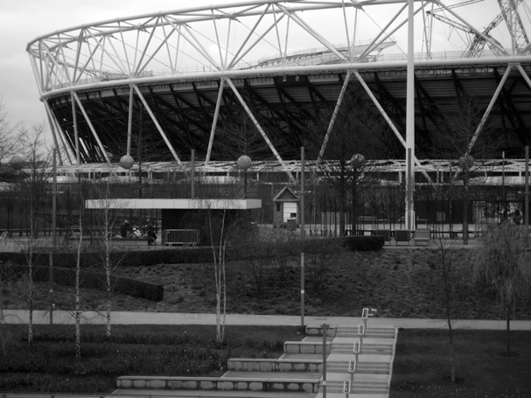 [Fig 1]

The view from ‘a shop that is not a shop’
Our study of the redeveloped QEOP was grounded in our observant participation in a mobile archive and residency space called the ‘‘Wick Common Shop”, between December 2014 and July 2015 [FIG.1]. The Shop was understood as a continuation of the ‘Wick Curiosity Shop’, an archival project begun in 2008 by public works and artist Hilary Powell that comprised books, pamphlets, films, maps and objects that interrogated the impact of the Games on the inhabitants, landscape and social life of the area (Powell and Marrero-Guillamón, 2012; Marrero-Guillamón, 2014; see also Harris, 2015). Displaying the archive in a 2.4m by 4.5m mobile wooden shed within the QEOP was intended to exhibit “the area’s unofficial and ‘minor’ history” (Wick Curiosity Shop, 2015), making visible alternative narratives and the areas’ pre-Olympic industrial and post-industrial history to evoke collective and self-organised practices. While designed to be mobile across the QEOP, the ‘Shop’ remained stationary in a square in the South Park, right beneath the Olympic Stadium. This section of the Park was designed as a series of contained urban squares or ‘rooms’ (LLDC, 2013b); except for the pre-existing waterways, it could be taken as an example of a “totally designed environment” (Degen, Desilvey and Rose, 2008). The presence of the fountains and a children’s play area, the ArcelorMittalOrbit, the adjacent E20 Café, and a line of catering kiosks [FIG. 2], led to a short-hand definition of the residency as a ‘shop that is not a shop’.
In response to the LLDC´s artistic commission as event-led programming, public works negotiated their presence as an open-ended residency: “a time and a space in which you can explore and produce work [with] an open brief” (Conversation, 23 February 2015). Moreover, the residency was shaped around the intention of producing intimate forms of public encounters in what was perceived as an inhospitable place mainly geared towards consumption and passive spectatorship. The practitioners contrasted a universalist understanding of publicness “[the LLDC] see the public as the public” with a relational one based on encounters: “if you want to create nearness, you have to spend time with people” (Ibid). To this aim, the residency involved small-scale workshops and had an open-door policy to encourage visitors to browse the archive and ask questions. The purpose of our participation in the residency was not to evaluate the success of the project, but to engage with critical spatial practices as a way of exploring significant and overlooked elements of contemporary urban dynamics (Rendell, 2006; Pinder, 2008).
As regular participants in the programme and the everyday activities in the Shop, we were able to gather different perspectives and discuss expectations and knowledges of visitors and local workers about a landscape still in the making, which challenged the presumption of a “submissive audience of the spectacle, anesthetised by aestheticisation and dulled by design” (Degen, DeSilvey and Rose 2008: 1908). The three themes in our theorisation of architecture of spectacle emerged through such encounters, conversations and observations, which enabled us to deploy a finer grained, semi-ethnographic approach to the ‘theme park’ urbanism of the QEOP (Smith, 2014). Over a six-month period, observant participation (Laurier 2016; Moeran 2007) was complemented by semi-structured interviews with LLDC officers working in public art commissioning and with members of public works. Content analysis of official images and ongoing documentation through digital photography were also undertaken both to keep a record of the rapidly changing landscape and to contribute to critiques of the use of images in the production of consensus through visual attempts at ‘shedding shadows on the Olympic spectacle’ (Marrero-Guillamón 2012). As collected in the Olympics Special Issue of Visual Studies (2012, 27 2), these attempts have sought to offer “wider visual perspectives” on spatial transformations before the Games, such as by offering visual counter-narratives to dominant imaginaries, as in Chilá and Dorley-Brown’s works, or by preserving memories, as in the works of Husni-Bey and Würfel. With the ‘un-staged’ landscape photographs that accompany this text we seek to illustrate our mundane, day to day experiences of the site and contribute to generating visual counter-narratives to dominant images.
Beyond the production of visual documentation, we engaged with Degen, Desilvey and Rose’s call for ‘an expanded understanding of visuality’ (2008) to examine how imaginaries of publicness are embodied and reproduced through use and everyday practices. To this aim we participated in devising small-scale critical interventions, ranging from workshop facilitation to visual displays, in an attempt to put ‘spanners in the spectacle’ and ‘think with conditions’ (Graham 2010). These interventions enabled us to further engage with visitors and interrogate moments of friction and negotiation, in the practices of invisibility, micro-regulation and disorientation informing the architectures of spectacle of the QEOP.

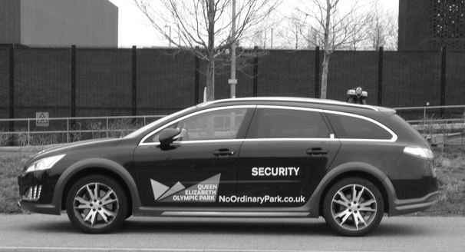[Fig. 2]

(In)visibility
The spectacle is informed by the policing of what and who is visible, and indeed the dominance of the visual and watching per se. In Debord’s words, “[t]he spectacle manifests itself as an enormous positivity, out of reach and beyond dispute. All it says is: ‘everything that appears is good: whatever is good will appear’” (1995 [1967]: 15). In the QEOP this manifested itself in the regulation and control over images and representations. In the run up to the London 2012 Games, preoccupation with city marketing was as significant as infrastructural change where imaginaries of a positive transformation of the Lower Lea Valley were important in generating public support (Raco, 2012). Being fenced off for construction for seven years, this large area of East London had been symbolically erased through what Raco and Tunney have described as a ‘blank slate’ narrative, suited to comprehensive redevelopment plans (2010) and to the marginalisation of its prior inhabitants and uses (Davis and Thornley, 2010). As noted by Gold and Gold, the impression that the regeneration of “physically blighted area would take place with little human cost [was] actively encouraged by developers, because it allow[ed] a conveniently dystopic image against which to juxtapose the shining future apparently on offer” (2008: 312). Images of a ‘shining future’ continue to be significant in the post-Olympic scenario, both in order to attract investors and tourists, and, importantly, to generate and maintain public confidence. In this, as argued by Davis, the ‘public’ of the Olympic legacy promise is “as much a speculative general public as it is any existing community” (2014: 338). The importance of public visibility is evidenced by a range of enacted regulations of visibility and invisibility in the Park, of which we identified three.
Firstly, the QEOP maintains a library of images and video selected by the London Legacy Development Corporation (LLDC) and the Olympic Delivery Authority (ODA) about the ‘construction, transformation and ongoing operation of the park’ for use by accredited media outlets. Visual content analysis of the 93 photos available showed that the library reproduced the promotion of the Olympic values: large-scale transformation, spaces for families, encouragement of healthy sport-related activities, and official public events and celebrations. These official representations can be seen as substantially in continuity with the official imaginary of the London 2012 Games and its “very political task of virtually assembling the future world” (Marrero-Guillamón 2012: 134). Images of families, celebrations and sun-kissed lounging on the grass, however, were distant from the landscape we encountered day to day during our six-month study. In contrast to the exceptionality of this ‘no ordinary park’ [FIG.2], consistently promoted through the use of superlative terms (“the first place in the world where...”, “the most successful Paralympic games ever”, “Britain’s tallest sculpture”), the un-staged mundane day-to-day South Park could be described as windswept and uneventful [FIG 3].
Secondly, photographing within the Park is restricted to personal use. Unsurprisingly for an international tourist destination, photographing and being photographed, against the backdrop of the park’s iconic architecture, such as the Stadium or the ArcelorMittal Orbit [FIG 4] is a common activity in the park. However, visitors wishing to film, photograph or record audio within the Park for anything other than personal use must obtain individual permission, which requires at least 10-day notice. Security guards admitted that enforcing the QEOP photography policy was a substantial part of their everyday security routine and that they would regularly question individuals with cameras that ‘looked professional’. While this is not dissimilar to other London parks’ requirements for commercial filming, it does indicate the extent to which the production of images of the park and their potential circulation are subjected to practices of control. In practice, however, enforcement remained inconsistent as the guards explained identifying ‘personal use’ and explaining copyright often proved difficult, particularly in an era of instant photo sharing through social media.
In contrast to the selected and controlled imaginaries of post-Olympic spectacle, the Shop aimed to function as a visual disturbance, both in terms of its ‘shabby’ external appearance and through the contents of its archive. The unspectacular size, shape and texture of the shed in which it was located were remarkable in their incongruity with the surrounding landscape and attracted curious visitors, several of whom drew parallels with self-built informal sheds in community allotments both in the UK and internationally. In response to these more autonomous and collective vernacular architectures, public works built a large billboard on the side of the shed to display a ‘shed of the week’ series based on captioned images of self-built and makeshift collective social spaces, between lawful and unlawful, [FIG. 5]. While the critical content of the archive displayed inside the Shop was accepted without vetting, the posters were subjected to a pre-screening and approval procedure by the LLDC’s Public Relations department and, at times, stringent visual and textual editing in line with the regulation and control of the images produced about the park itself. This often involved lengthy email and in-person negotiations and in one instance led to refusal, when the image of a community shed from Hackney Wick, locally known as ‘tipsy tiger’, was considered problematic as its association to alcohol consumption could inconvenience families and “the wider public” using the area, despite the fact the only indoor café in the vicinity displayed and sold alcoholic drinks. The management of visibility and invisibility was thus manifested in control over the production and circulation of images of the park, as well as in the control over the images that were allowed to appear publicly within it. In the management of appearances, who and what is visible contributes not only to particular narratives of publicness and but also create “the conditions of possibility for how we act, which itself creates the contours of that very space” (Watson, 2006: 8). Appearances are thus fundamental to the spectacular post-Olympic logic of the park. To understand their relation to the production of new open spaces, it is necessary not only an expanded understanding of visibility, but also a critical approach to the ways in which, in practice, publicness and publics are summoned to justify forms of surveillance and micro-regulation.

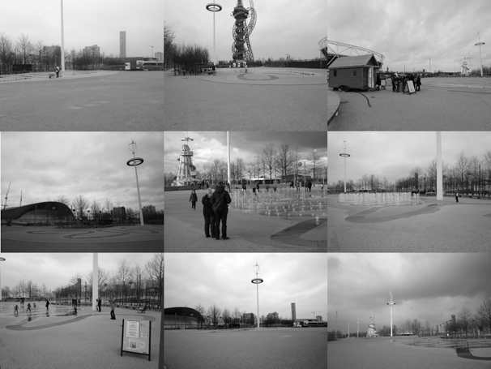[Fig. 3]
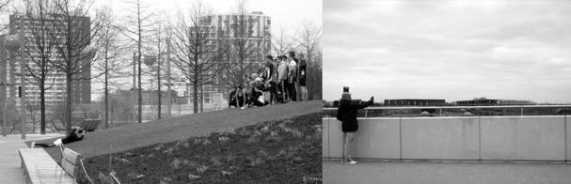[Fig. 4]
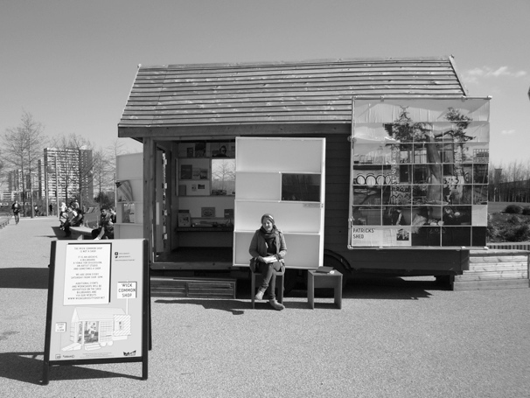[Fig. 5]

Micro-regulation
Acting in conjunction with the control of images in and of the park, a second element of our discussion of architectures of spectacle concerns the micro-regulation of use. As noted by Don Mitchell, the regulation of public spaces is often informed by “the ideal of a fully controlled space in which the public basks in the splendour of spectacle but is never at any sort of ‘risk’” (2003: 233-234). In the construction and delivery of the Olympic Games, ideals of risk free environments have been used to justify the militarisation of spaces (Graham, 2012) and ‘exceptional’ measures and such technologies of facial recognition CCTV, microphones and Automatic Vehicle Tracking. As argued by Fussey et al. such measures are then embedded into the ‘security legacy’ of Olympic-led regeneration projects both physically as well as symbolically in order to “promote a particular tenor of order and attract particular types of users” (2011: 39).
The South Park of the QEOP is a highly regulated space subject to total, close-up, 24-hour surveillance, which reveals a substantial continuity with the highly securitised space pre- and during the Games. The legacy of ‘fluid forms of soft and hard surveillance’ (Manley and Silk 2013: 371), moreover, combined with more lasting legislative changes, such as the introduction of bylaws to regulate who and what can appear, and what is permissible activity (Lenskyj in Fussey et al., 2011). In the case of QEOP, regulation through bylaws and surveillance apply to many activities that would be considered conventional in a park, such as picnics and organised sports and games [FIG. 6]. When asked about his job, a security officer on patrol commented that there wasn’t much to monitor because “you can’t do anything in the park!”, as even a friendly football game required written permission. Another guard commented - tongue-in-cheek - that often his role was “birth control”: informing teenage couples kissing in less exposed areas that, nonetheless, “they are on CCTV”. As an example of direct regulation and control of behaviour through normatively defined notions of appropriate conduct in public spaces (Watson, 2006), local young people have been shown to be disproportionately affected by the spatial restructuring of global host cities (Kennelly and Watt 2011). Youth-oriented surveillance on the QEOP could therefore be seen as an extension of the targeting of young people in Stratford before and during the Games (see Kennelly and Watt 2013). In practice, however, it was admitted to a public works member that surveillance of appropriate behaviours was at times discretionary: “sometimes [the guards] look through their fingers because they might personally feel that the regulations of the park are way too restrictive, saying that a park doesn’t feel like a park if you can’t have a picnic, and your dog has to be constantly on a leash” (Conversation 13 July 2015).
The impact of regulation on everyday activity became a focus of two workshops held as part of the residency, which reveal the contradictions between a brief to ‘activate’ the space through public engagement and the difficulties of doing so even when prior permission has been given. In response to Article 42 of the bylaws that restricts kite flying within the Park, two design students planned and facilitate a public kite-making workshop in the Shop [FIG. 7] which attracted a group of pupils from a local secondary school. Within minutes of the kites in flight, the group was stopped by a security guard who informed them that it was forbidden to fly kites because the QEOP was “a private-public park”. When asked for further explanations, the students were told that if they wanted they could move to an empty area of tarmac over Carpenters Way, behind the Olympic Stadium construction site and away from the fountain and the families. The swift arrival of the guard was evidence of the tight surveillance of the South Park, a clear legacy of the Games’ “powerful and intense” CCTV infrastructure (Fussey et al, 2011: 193). A similar incident occurred during a one-day workshop on rope making through recycle fabrics. Testing a newly made rope by skipping, the students were stopped by a guard within minutes [FIG.8]. After explaining that the workshop was part of a residency approved by the LLDC (and that we had dutifully completed a risk assessment for the workshop), they were asked for the name of a contact within the organisation, which was checked over a walkie-talkie. These two examples exposed the tension between a commission aimed at ‘animating’ the park through public activities and practices of micro-regulation geared towards the ‘utopia’ of a perfectly risk-free public space.
Further to the surveillance of public activities, the complex private-public regulatory frameworks examined in the delivery of the Games (Raco 2014), filtered to the micro-management of the mobile commission itself, whose eventual immobility revealed both competing priorities and multiple layers of the management of appearances in the Park. In the initial agreement with the LLDC, the Shop was to be mobile across four different locations in the North and the South Park and to this aim was equipped with wheels and towing fixtures. However, once on site mobility proved impossible. In long and on-going discussions about other possible locations, the most significant barrier was that the presence of the Shop would conflict with other programming, particularly private hire by corporations and charities, because, as explained by an LLDC officer, private events “cross-subsidise non-commercial use”. As the LLDC are funded by taxpayers, their obligation to taxpayers is to generate revenue; in this logic, commercial and non-commercial uses have to be carefully balanced. As tarmacked avenues were used for races and temporary events, the alternative idea of parking the Shop on the lawn a place ‘not ‘designated as public access’ raised ‘technical difficulties’. The private firm hired by the LLDC with managing the park, cited potential damage to the grass, with high associated restoration costs, the hazards posed to visitors by muddy puddles and the possibility that the weight of the cabin could damage the underground drainage system in areas where the soil was ‘too thin’. During a meeting with a commissioning officer of the LLDC, public works was told that the gardeners had “very high standards of immaculate gardens” and that, in fact, “the park was not designed to have things happen on grass” (Conversation, 1 May 2015).
These minor instances of micro-regulation through surveillance and management of use in the QEOP are examples of the ‘security legacy’ of the Games that signal two key contradictions in the ‘public’ delivery of its legacy. Firstly, is that great importance is given to the appearance of the park and the activities that take place within it, which are both explicitly and implicitly surveilled for appropriateness, even when they had been given prior permission. In this sense, the micro-management of activities can be seen as an extension of the regulation of visibility, which becomes particularly paradoxical in the case of a spectacular landscaping practice that does not envisage using the lawns. Secondly, the micro-management of use becomes a necessary tool for maintaining the priority of private hire over public uses, even when these were commissioned. As an urban development corporation, the LLDC is responsible for ensuring that “public money is […] used economically, efficiently and effectively”. In this sense the benefit for the public, as taxpayers, lies in gaining economic benefits as investors, pitted against the ‘soft’ benefit of actually using the park. In other words, open use is constantly confronting the demands of regulating space and generating revenue, with two understandings of the public – as users and as taxpayers – mobilized and counterposed in the explanation of the commissioning officers. As observed by Juliet Davis in her analysis of the Olympic legacy masterplan, flexibility and regulation, “two faces of a democratic urban assemblage, do not seem to sit easily together” since what one “can offer by way of ‘benefits’ on grounds of public value, the first can in theory strip on the basis of economic viability and capital value” (Davis, 2014: 338). While surveillance and micro-management became visible through activities critically designed to test their boundaries, the static ‘mobile’ residency revealed a landscape in the making that was already riddled with competing values.

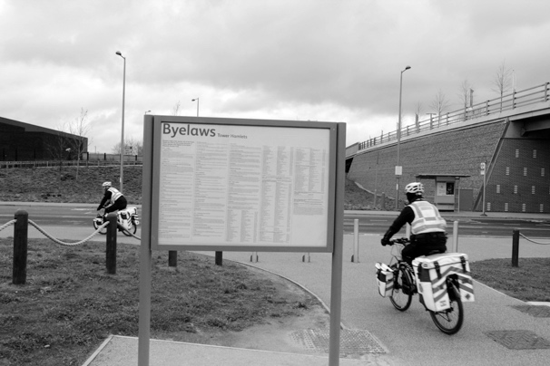[Fig. 6]
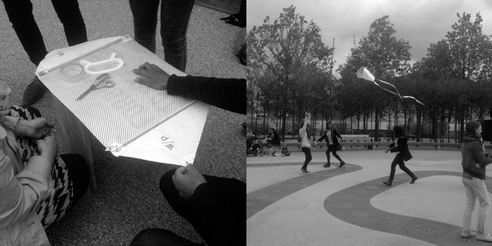 [Fig. 7]
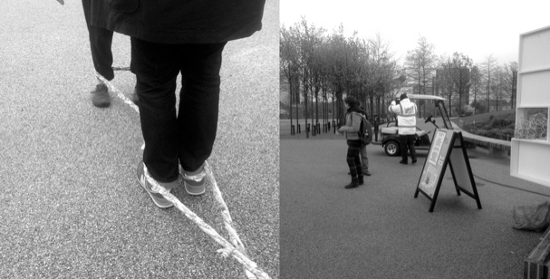 [Fig. 8]

Disorientation
Finally, in addition to the primacy of images over use and to micro-regulations and surveillance, a third important element of the architectures of spectacle identified in the QEOP was the sense of disorientation produced by the spectacular landscaping and its amnesic relation to pre-Olympic. A number of visitors, from elderly couples to families and young professionals commented about finding the official maps, scattered around the landscape on information columns, “disorienting”, leading them to enter the Shop to ask for information. The ensuing conversations were revealing of expectations and attitudes. The arrival by coach of tourists from the UK and from other Europe countries was an indication of the site’s growing reputation as a tourist destination, often on a sightseeing list alongside attractions such as the London Eye and St Paul’s Cathedral. Their main question upon entering the Shop, however, was “where is the Olympic Park?” The answer was met with suspicion and disbelief: common reactions involved looking around at the gravel, tarmac and manicured flowerbeds tarmac, or repeating their question to make sure that we had understood what they were looking for: “a park, you know, with grass!” (Conversation 21 March, 2015)
In response to these encounters and questions, as part of the residency we began drawing a large-scale map of the site at the time of the Olympic bid in 2005, with a particular focus on pre-Olympic spaces of socialisation, such as Hackney Stadium, used for speedway to greyhound racing, and eventually for car-boot sales; the Manor Gardens Allotment, displaced by the Games, and the cooperative housing Clays Lane Estate, now demolished. We overlaid a transparent sheet and added the sites of the redeveloped QEOP. The maps, hung on the wall at the entrance of the shed, rapidly became a talking point [FIG. 9]. In some cases, the visitors’ surprise was directed at the sheer extension of the commercial and residential new development in contrast to the “narrow strip” of the public green areas. For others, the surprise was in realising the limited distance to Hackney Wick, which did not appear on the official maps of the QEOP. New visitors and residents ignored that Hackney Wick Overground station was equidistant to East Village as Stratford Underground station. A new tenant of East Village in his thirties confessed that despite visiting the Park often, he had only been to Hackney Wick by Overground and did not know that there were bridges connecting the two. In several cases visitors confessed to being puzzled that they should be “forced” to walk through Stratford shopping mall to reach the park, when the other station was so close; in one case, a woman remarked that she had explicitly been told not to get out with her children at Hackney Wick station and this made her feel “manipulated”. A young family, who had also recently moved to East Village and visited the park often with their three-year old child, admitted that they were not even sure that Hackney Wick “still existed” (Conversation 21 March 2015). Disorientation is thus an integral part of the production of the spectacle, and the loss of reference points is as temporal as it is spatial, and parallels could be drawn with the production of navigational paths through the ‘stagecraft’ of retail design (Kulkarni and Joseph-Lester, 2004).
In the reorientation following the disorientation of the comprehensive redesign, opinions on the park varied widely, in correspondence, to a degree, to the existence of prior knowledge and attachment to the place. A significant proportion of residents from the local area, across a range of ages, genders and backgrounds, held strong negative opinions, referring to the park as “clinical”, a “vast expanse of concrete”, “artificial”, “very bleak and desolate” [FIG. 10]. Some criticised its commercial nature, defining it as “an outdoor shopping mall”. Even parents with young children, who usually endorsed the playground areas and the fountains, lamented the fact that they had to pay for all indoor attractions. Less critical responses came from the new residents of the redeveloped Athletes’ village, the first residential neighbourhood in the QEOP which had recently opened (November 2013). Although common remarks included that the place felt “a bit artificial”, “very manufactured” and “strange”, there was widespread resignation. The majority tended to share the view that they “couldn’t imagine how [the LLDC] could have done it otherwise”, being a newly developed space, and that efforts were being made to improve it through landscaping. Furthermore, resignation intertwined with an acceptance of the spectre of a failed legacy. As also reflected by a member of public works, most of the positive comments echoed the opinion that “at least this park is being used, whereas other Olympic stadiums and parks are just left empty, like ghost towns” (Conversation 13 July 2015). This can be interpreted as revealing a wider awareness of the history of Olympic planning and the recurrent inability of host cities to realise positive legacies (Davies, 2014), and an acceptance of the mobilisation of imaginaries of failure to justify privatisation and speculative development. In this context, the Shop’s presence and its archive functioned as a reminder of other possible uses. Its maps and literature made visible what had been erased in the production of a ’blank slate’ narrative, but also how the separation of the Park from the surrounding neighbourhoods was perpetuated through its visual representations, built environment design, cartographic practices and on-site signage. The post-Olympic spectacle of the QEOP can thus be seen to function by disorienting and attempting to reorient visitors and residents towards habituation to a new spectacular publicness, leading to ambivalence, disappointment and, at times, critique and rejection.

Conclusions

As has been widely argued, urban transformations caused by the London 2012 Olympics has brought about a range of social injustices, both in preparation and during the Games, through the marginalisation and displacement (Davis and Thornley 2010; Kennelly and Watt 2012; Watt 2013) of local communities, as well as through increased militarisation and surveillance of the area (Graham 2012). In this article we have drawn on participant observations and visual documentation to examine how the Olympic legacy has not only made invisible past injustices, but has also generated new exclusionary forms of social and spatial control. Looking at the first year of the most public promise of the London 2012, a ‘new park’ for East London, we have shown how the post-Olympic legacy is informed by an architecture of spectacle that links back to pre-Games discourses and practices. In our analysis we have identified three main components of this architecture: managed (in)visibilities, micro-regulation of uses and disorientation, and have examined their claims to publicness as key to the production of the legacy.
“Defence of the spectacle has become the central feature of Olympic planning” (Fussey et al 2011: 2) and this remains true in post-Olympic planning and its ‘security legacy’. In place of a sporting mega-event, however, what is being secured now is the appearance and experience of the area, and particularly of the park, as a ‘risk-free’ space. In this, a security infrastructure previously geared towards preventing and responding to threats such as terrorism, has been transformed into a mechanism for surveilling the more mundane perceived ‘threats’ of inappropriate images, behaviours and activities. By including examples of visual documentation in the article we have aimed to counter the managed invisibilities of this new ‘private-public park’, contributing to existing work on the role of the visual to both produce and challenge consensus about the London 2012 Games (Marrero-Guillamón, 2012). Looking at claims to publicness, we have shown how the ‘speculative general public’ of the legacy promise (Davis 2014) was conceived and summoned as simultaneously users and as investor-owners to justify tight control over both representations and activities in the park. The unspoken but underlying rationale for such arguments is that the park needs to be maintained as added value for the residential and commercial developments that surround it; another clear example of how the “beautification of public space is used to jump-start private property development” (Staeheli and Mitchell, 2008: 54).
Direct participation in a commissioned cultural residency programme enabled a situated and detailed examination of how this spectacular logic is normalised in everyday practices in the park. It also offered a critical platform for observing and contributing to small-scale critical interventions that served to reveal and publicly interrogate how this logic operates. The public activities of the residency, namely the archive, the billboard, the production of critical maps and the workshops, all tried to intervene by providing a counter point to “all that appears is good” (Debord, 1967) while also creating moments for reflecting on the construction and maintainance of the post-Olympic spectacle. In such a context, critical processual practices of art-architecture, uneasy about their incorporation into place-making agendas, remain relatively weak players, even on a symbolic level. Nonetheless, in this case they opened up a space of encounter with local residents, visitors and workers which challenged the presumption of an audience submissive to the spectacle, and revealed instead awareness and at times, critique. The ensuing conversations give important indications of tensions between the ‘speculative general public’ of the Olympic legacy and occasional and regular users of the QEOP. The question remains as whether the discursive and material framing produced by post-Olympic architectures of spectacle will succeed in the long run in marginalising and silencing these tensions, the site’s contested past and its potential alternative uses.

References

BERRY-SLATER and ILES, A. (eds) (2009) No room to move: radical art and the regenerated city. London: Mute Publishing.

BORDEN, I., KERR, J., RENDELL, J. and PIVARO, A. eds. (2002) The Unknown City: Contesting Architecture and Social Space. MIT Press.

BLUNDELL-JONES, P., PETRESCU, D. AND TILL, J., eds. (2005) Architecture and Participation. London: Spon Press.

BOURRIAUD, N. (2002) Relational Aesthetics. Les Presses du reel.

CHALKLEY, B. and ESSEX, S. (1999) “Urban Development through Hosting International Events: A History of the Olympic Games.” Planning Perspectives 14 (4): 369–94. doi:10.1080/026654399364184.

DAVIS, J. and THORNLEY, A. (2010) Urban regeneration for the London 2012 Olympics: issues of land acquisition and legacy. City, Culture and Society 1 (2), 89-98.

DAVIS, J. (2014) A promised future and the open city: issues of anticipation in Olympic legacy designs. Architectural Research Quarterly 18 (4), 324-341.

DEBORD, G. (1995 [1967]). The Society of the Spectacle. Translated by Donald Nicholson-Smith New York; Zone Books.

DEGEN, M., DESILVEY C. and ROSE, G. (2008) Experiencing visualities in designed urban environments: learning from Milton Keynes, Environment and Planning A 40(8), 1901-1920.

DEUTSCHE, R. (1998) Evictions: Art and Spatial Politics. Cambridge MA: MIT Press.

DORLEY-BROWN, C. (2012) “The Cut.” Visual Studies 27 (2): 120–25.

FRIELING, R. and GROYS, B. (2008) The Art of Participation: 1950 to Now. London: Thames & Hudson.

FROOME-LEWIS, O., 2014. ‘Lea Valley Drift: paths, objects and the creation of urban narratives.’ In arq 18(4): 377–388.

FUSSEY, P. COAFFEE, J. and HOBBS, D. (2011) Securing and Sustaining the Olympic City. Reconfiguring London for 2012 and Beyond. London: Ashgate.

GOLD, J. R. and GOLD, M.M. (2008) “Olympic Cities: Regeneration, City Rebranding and Changing Urban Agendas.” Geography Compass 2 (1): 300–318

GRAHAM, J. (2010) Spanners in the Spectacle: Radical Research at the Front Lines, Fuse Magazine 33(2) [online].

GRAHAM, S. (2012) Olympics 2012 security, City: analysis of urban trends, culture, theory, policy, action, 16(4), 446-451.

HARRIS, A. (2015) Adventures in the art of dissent and London's Olympic State, City: analysis of urban trends, culture, theory, policy, action, 19(1), 121-125.

HOPKINS, J AND NEAL, P (2013) The Making of the Queen Elizabeth Park. London: John Wiley & Sons.

IMRIE, R. AND RACO, M. (1999) “How New Is the New Local Governance? Lessons from the United Kingdom.” Transactions of the Institute of British Geographers 24 (1): 45–63.

IMRIE, R. and THOMAS, H. (1999) British Urban Policy: An Evaluation of the Urban Development Corporations.

IVESON, K. (2007) Publics and the city. Oxford: Blackwell.

JONES, A. (2016) ‘Orchestrated Public Space. The Curatorial Dimensions Of The Transformation Of London’s Southbank Centre.’ Originally published in: Golchehr et al. (eds.) Mediations: Art & Design Agency and participation in public space, conference proceedings. London, UK : Royal College of Art, 2016, pp. 244-257. Available: http://eprints.lse.ac.uk/68373/1/Jones_Orchestrated%20public%20space.pdf

KENNELLY, J. and WATT, P. (2011) Sanitizing public space in Olympic host cities: The spatial experiences of marginalized youth in 2010 Vancouver and 2012 London. Sociology, 45(5): 765-781.

KENNELLY, J., & WATT, P. (2012) Seeing Olympic effects through the eyes of marginally housed youth: changing places and the gentrification of East London. Visual studies, 27(2): 151-160.

KENNELLY, J. and WATT, P. (2013) Restricting the public in public space: the London 2012 Olympic Games, hyper-securitization and marginalized youth, Sociological Research Online 18(2), http://www.socresonline.org.uk/18/2/19.html.

KULKARNI, N. and JOSEPH-LESTER, J. (2004) Disorientation and Spectacle in Retail Architecture. London: Artwords.

KWON, M. (2002) One Place after Another. Site-Specific Art and Locational Identity. Cambridge, MA: MIT Press.

LACY, S., ed. (1995) Mapping the Terrain. New Genre Public Art. Bay Press.

LAURIER, E. (2016) “Participant and Non-Participant Observation.” In Key Methods in Geography, edited by Nicholas Clifford, Meghan Cope, Thomas Gillespie, and Shaun French, Third edition, London: Sage. 169–81

LEVIN, L. and SOLGA, K. (2009) Building Utopia: Performance and the Fantasy of Urban Renewal in Contemporary Toronto, The Drama Review 53, 45.

LLDC (2015) London Legacy Development Corporation Local Plan 2015-31. London: LLDC.

LLDC (2013) ‘A Walk around the Queen Elizabeth Olympic Park’. London: LLDC.

MADDEN, D. J. (2010) “Revisiting the End of Public Space: Assembling the Public in an Urban Park.” City & Community 9 (2): 187–207.

MANLEY, A. and SILK, M. (2013) “Liquid London: Sporting Spectacle, Britishness & Ban-Optic Surveillance.” Surveillance & Society 11 (4): 360–76.

MARRERO-GUILLAMÓN, I. (2012) “Photography against the Olympic Spectacle.” Visual Studies 27 (2): 132–39.

MARRERO-GUILLAMÓN, I. (2014) Together apart: Hackney Wick, the Olympic site and relational art. Architectural Research Quarterly, 18(04), 367-376.

MILES, M. (1997) Art Space and the City: Public art and urban futures. London: Routledge.

MINTON, A. (2009) Ground Control: Fear and happiness in the twenty-first-century city. London: Penguin.

MITCHELL, D. (2003) The Right to the City: Social justice and the fight for public space. New York and London: Guilford Press.

MOERAN, B. (2007) “From Participant Observation to Observant Participation: Anthropology, Fieldwork and Organizational Ethnography.” Creative Encounters Working Papers, 1–25.

PETRESCU, D. (2007) 'How to make a community as well as the space for it', in Re-public: Reimagining Democracy, http://www.re-public.gr/en/?p=60 [accessed 1 May 2015].

PINDER, D. (2008) Urban Interventions: Art, Politics and Pedagogy. International Journal of Urban and Regional Research 32(3), 730-736.

POWELL, H., & MARRERO-GUILLAMÓN, I. (eds) (2012) The art of dissent: Adventures in London's Olympic state. Marshgate Press.

POYNTER, G. (2009) ‘The 2012 Olympic Games and the reshaping of East London’, in Imrie, R., Lees, L., & Raco, M. (Eds.) Regenerating London: governance, sustainability and community in a global city. London: Routledge.

PRATT, A.C. (2009) Urban Regeneration: From the Arts `Feel Good' Factor to the Cultural Economy: A Case Study of Hoxton, London. Urban Studies 46, 1041-1061.

RACO, M. and TUNNEY, E. (2010) “Visibilities and Invisibilities in Urban Development: Small Business Communities and the London Olympics 2012.” Urban Studies, March.

RACO, M. (2012) The privatisation of urban development and the London Olympics 2012. City: analysis of urban trends, culture, theory, policy, action, 16(4), 452-460.

RACO, M. (2014) Delivering Flagship Projects in an Era of Regulatory Capitalism: State-led Privatization and the London Olympics 2012. International Journal of Urban and Regional Research, 38(1), 176-197.

ROSLER, M (2010) Culture Class: Art, Creativity, Urbanism, Parts I, II and III. In E-flux, http://www.e-flux.com/journal/culture-class-art-creativity-urbanism-part-i/ [accessed 1 November 2011].

RENDELL, J. (2006) Art and architecture: a place between. London: I. B. Tauris.

SADLER, S. (1999) The Situationist City. MIT Press.

SAUNDERS, W.S. ed. (2005) Commodification and Spectacle in Architecture. Harvard Design Magazine Reader. Minneapolis: University of Minnesota Press.

SHIN, H. B. (2012) Unequal cities of spectacle and mega-events in China, City: analysis of urban trends, culture, theory, policy, action, 16(6), 728-744

SMITH, A. (2014) “From Green Park to Theme Park? Evolving Legacy Visions for London’s Olympic Park.” Arq: Architectural Research Quarterly 18 (4). /core/journals/arq-architectural-research-quarterly/article/div-classtitlefrom-green-park-to-theme-park-evolving-legacy-visions-for-londonandaposs-olympic-parkdiv/99207F31FCAB7FCBBD11EB3B48BA839A.

SORKIN, M. ed. (1992) Variations on a Theme Park: The New American City and the End of Public Space. New York: Hill and Wang.

STAEHELI, L. A., and D. MITCHELL (2008) The People’s Property? Power, Politics and the Public. New York and Oxon: Routledge.

SURBORG, B. VANWYNSBERGHE, R. AND E. WYLY (2008) Mapping the Olympic growth machine, City: analysis of urban trends, culture, theory, policy, action, 12(3) 341-355.

VICKERY, J. (2007) The emergence of culture-led regeneration: a policy concept and its discontents. Working Paper. Coventry: University of Warwick. Centre for Cultural Policy Studies (Research papers).

VIDLER, A. (2008). Introduction to Architecture: between spectacle and use. Vidler, A., ed., (New Haven: Yale University Press) pp. vii- xiii.

WARNER, M. (2005) Publics and Counterpublics. New York: Zone Books.

WATSON, S. (2006) City publics: the (dis)enchantments of urban encounters. Psychology Press.

WATT, P. (2013) ‘It's not for us’, City: analysis of urban trends, culture, theory, policy, action, 17(1), 99-118.

WICK CURIOSITY SHOP (2015) <http://r-urban-wick.net/blog/wick-curiosity-shop-blog/861/callout_mini-residency-at-the-wick-common-shop>

WOLFF, N. and GIBBONS, A. (2012) Introduction: Unpacking the Olympic spectacle: ‘Faster, Higher, Stronger’ from London to Rio to China. City: analysis of urban trends, culture, theory, policy, action, 16(6), 725-727.

See also City 16(4), (5); vol. 17(1); and vol. 19(1).
The residency was called ‘The Wick Common Shop’, commissioned by the LLDC to the art-architecture Studio public works, see http://r-urban-wick.net/blog/o=10
The phrase architecture of spectacle was the title of a symposium on the London 2012 Olympic organised by the Centre for Urban & Community Research, Goldsmiths College, at the Whitechapel Gallery on the 6th July 2012. The participation of public works and one of the authors laid the theoretical ground for this research collaboration.
Activities, such as the drift and psychogeographic map-making, once devised by the Situationists as a means to ‘puncture’ spectacle, have been incorporated into the QEOP’s cultural commissions, see the ‘Lower Lea Valley Drift Map’ by Oliver Froome Lewis and Chloe Street, commissioned by the LLDC (Froome-Lewis, 2014).
This expression became a descriptor for the ‘Wick Common Shop’ residency in response to its questioning by visitors and nearby shop-keepers who asked what it was selling.
Queen Elizabeth Olympic Park, ‘Image Library’ http://www.2012imagelibrary.co.uk [accessed 12 January 2016].
The 93 images are categorised as Events (18 images), General Park Shots (21 images), People (8 images), Venues (38 images), Transformation (17 images). Over half of the images available represent the physical venues and the building work (55 images). Nearly a third include the ArcelorMittal Orbit, in its role as landmark, often in aerial photos of the site under construction or completed. Over a third show individuals and families with young children in organised events in the park, either as spectators or doing sports, in the park; a selection of which, categorised as ‘people’, is dedicated to middle-aged white men in suits (national media journalists, the landscape designer, the mayor of London, one of the princes) posing for the cameras or performing public acts. Interestingly, in the ‘General park shots’ category 16 out 21 photos were taken in visibly warm days in spring or summer, revealing a very blue sky or only thinly clouded, with visitors and children wearing t-shirts and shorts.
See also Queen Elizabeth Olympic Park, ‘Filming in the Park’ http://queenelizabetholympicpark.co.uk/media/filming-in-the-park [accessed 3 June 2015].
See, for instance, for Royal Parks, ‘Filming in the Royal Parks’ https://www.royalparks.org.uk/press-and-media/filming-in-the-royal-parks [10 January 2016].
Article 42 ‘Kites’ of the Bylaws states: (1) Where any part of the park has, by notices placed in conspicuous positions in the park been set aside by the Council as an area where kite flying is permitted, no person shall fly or cause or permit to be flown any kite in any other part of the park. (2) No person shall fly any kite in such a manner as to cause danger or give reasonable grounds for annoyance to any other person.”
The workshop and the DIY kite kits were designed by MA Industrial Design students from Central Saint Martins Andrea Nicholas De Montis and Joao Braganca Gil.
The workshop, titled Ropewalk was conducted by Rachel Matthews for a cohort of second year BA Textiles students from Central Saint Martins.
The four locations proposed were: the first in the South Park; the second in the West side of the North Park; the third, also in the North Park, near the play areas; and, finally, in the community gardens of the Chobham Manor development, by East Village.

