https://creativeeducationnetwork.com/2018/05/09/internationalising-the-curriculum/

Internationalising the curriculum
Posted on May 9, 2018 by tonyjreeves
Guest blog post by Dr. Tomasz John, Coordinator and Lecturer for UCA’s Pre-sessional English for Art and Design courses.
Over the next few years, UCA “will become a leading force for innovation in international creative education. This will be achieved through a co-ordinated, collaborative and agile approach that will enable the University to operate effectively and efficiently in today’s changing global educational market.” This quote from our new International Strategy indicates that we will all need a more comprehensive understanding of how to support international students effectively.
It is predicted that by 2022/23 the University’s international student numbers will significantly grow at our campuses in the UK, and on UCA programmes overseas. One of the supporting objectives of the strategy refers to curriculum development in a global context, requiring enhancement of the internationalisation of the curriculum and international integration activities. The expectation is that the majority of programmes will embrace the study of creative practice and its management within the context of international consideration of course content.
Central to this strategy is the need to ‘internationalise the curriculum’. But what does this mean, and how do we go about it?

Adopting a global perspective
Knight (2004, 11) claims that internationalization of curriculum encompasses the process of integrating an international, intercultural or global dimension into the purpose, functions or delivery of post-secondary education. Nillson (1999) argues that it’s a curriculum that gives all students an education that will equip them to live and work successfully in globalised world. And according to Schoorman (2000, 2), internationalised curricula provide ‘counterhegemonic educational process that challenges current content and pedagogy and offers a transformative educational experience’.
UCA’s newly-formed Department of International Studies with its International Pathway Programmes (IFADM, GDAD, PSEAD) provides a good starting point for leading the shift to a more international approach to curriculum design. For example, the Pre-sessional English for Art and Design (PSEAD) is much more than just a language course that ‘fixes’ students’ English – it’s impossible to do this in just a few weeks. Instead, the course focuses on embedding ‘intercultural competencies’ within the curriculum, which can be understood as ‘abilities to develop targeted knowledge, skills and attitudes that lead to visible behaviour and communication that are both effective and appropriate in intercultural interactions’ (Deardorf, 2006).
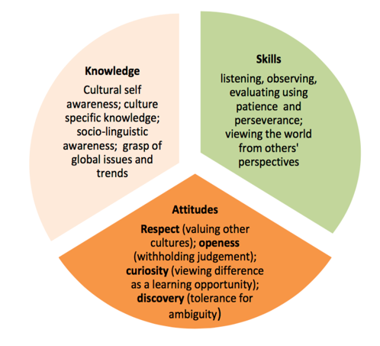
Examples of intercultural competencies (adapted from Deardorff, 2006)
If a key role of Higher Education is to develop global citizens, then embedding intercultural competencies in curricula is vital to achieving this aim.

What does this look like in practice?
The following is an example of one of our set project briefs, which takes an approach that is integral across UCA and other creative arts education institutions in the UK and more widely. It is an effective way of structuring the various content-based elements and cascading them into skills.
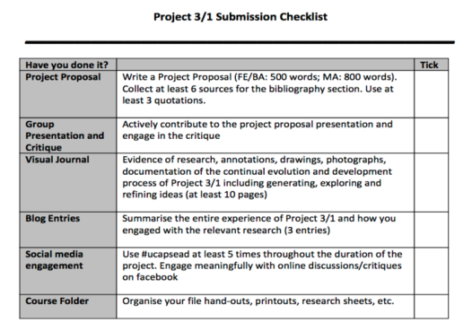
There are a number of short creative arts-related projects on all 5, 10 and 15-week courses, and intercultural competencies are embedded in all projects. Each project has a different emphasis ranging from embracing what international students bring with them from their cultures as well as introducing them to local/British traditions, e.g. Mapping Cultural Heritage, Journey Limitless, Art and Activism and Better Future.
The pre-sessional EAP course doesn’t follow the sometimes irrelevant IELTS-like approach. Instead, the course successfully incorporates appropriate study skills that the students will be expected to master when they progress to their main courses at UCA, e.g. engaging with critical thinking through reading key texts, ability to take part in an art critique or write a variety of creative arts-related texts (reflective and evaluative blog entries, art reviews, essays, publications, scripts, etc.). The course also hinges around a number of formative assessment points at the end of each project. At these points, the aims and learning outcomes are used in conjunction with students’ self-evaluation and peer assessment methods to evaluate each student’s academic progress. Meaningful assessment methods are being used to evaluate the development of intercultural competencies both throughout and at the end of the projects to aid students’ learning on their intercultural journey.
For example, the Art and Activism project enables students to explore their interest in creative arts. The learning activities empower students to develop targeted knowledge, skills and attitudes, leading to visible behaviour and communication that are both effective and appropriate in intercultural interactions. At the beginning of the project, students work in multicultural groups in order to examine and address the concept of dialogue through creative arts as a method of communication to confront issues they care about. Through a combination of field trips, lectures, workshops and seminars, students investigate the work of international artists and designers.
The course provides opportunities to collaborate with local artists, helping the students learn how to carry out effective academic research and also write empowering proposals. These proposals are then transformed into inspiring and imaginative performances, presentations and installations, in which students clearly demonstrate a variety of intercultural competencies.
What’s really special is that at the end of the course, students celebrate their academic achievements by producing an ISSUU. This is a digital publication that draws on all the skills they have learned on the course, including:
- multicultural group work
- taking part in art critiques and presentations
- research skills: avoiding plagiarism, summarising and paraphrasing
- using Harvard Referencing system
- reflective and evaluative writing
- text editing/peer reviewing and proof-reading in Microsoft Word
- image/moving image editing/peer reviewing and proof-reading in Adobe Creative Cloud
The publications are then sent directly to the students’ future course leaders alongside academic performance reports, which help to inform the diagnostic process. The feedback we’ve received is that the publications and the reports make a huge difference in catering for the students’ needs on the main courses, e.g. identifying further EAP support provided by the Learning and Development Tutors. If you’d like to see more, have a look at some examples.

What do students think?
Feedback received through the end of the course internal surveys and the i-Barometer survey in the past has been very positive. Students indicate that they greatly value the ability to develop intercultural abilities through art contextualised projects, rather than focusing solely on improving their language skills.
The pre-sessional course provides a valuable opportunity for students to link continents and bridge cultures as they collaborate on their projects. My hope is that the increased focus on internationalisation will bring a richer learning experience, not just for our international students but also for the wider UCA student community.
We’re looking for guest lecturers and speakers to contribute to our summer 2018 PSEAD programme in Epsom. If you want to get to know your students before they start their main courses in September 2018, and you’re interested in integrating your course’s pre-arrival task to engage your students with it, this might be your chance! Please get in touch!
Dr Tomasz John,
tjohn@uca.ac.uk

Bibliography
Deardorff, D. K. (2006), The Identification and Assessment of Intercultural Competence as a Student Outcome of Internationalization at Institutions of Higher Education in the United States, Journal of Studies in International Education 10:241-266
Nilsson, B. (1999). Internationalisation at home – theory and praxis. EAIE Forum, Spring, 12.global levels. Development Education ontemporary Education, 71 (4), 1-13.
Reid and Spencer-Oatey, (2014), 2006)Towards the global citizen: Utilising a competency framework to promote intercultural knowledge and skills in higher education students, in Cross-Cultural Teaching and Learning for Home and International Students by Ryan (2014), Routledge
Schoorman, D. (2000). What really do we mean by ‘internationalization’. C Knight, J. (2004). Internationalization Remodeled: Definition, Approaches, and Rationales, Journal of Studies in International Education 2004 8: 5

