becoming-one ; a duologue in practice
Emmanuelle Waeckerle and Manuel Vason
Abstract
We became one in writing and in breathing, in real time and in photographic time. The images are there to prove it, as well as our memories of the experience and our attempt at sharing, comparing, articulating and putting into words what happened to us before, during and after this extra-ordinary human and posthuman encounter.

Emmanuelle Waeckerle
Reader in Photography and Relational practices
University for the Creative Arts
Falkner Rd
GU9 7DS Farnham, UK
ewaeckerle@uca.ac.uk
moi@ewaeckerle.com

Manuel Vason
PhD by publication
University for the Creative Arts
Falkner Rd
GU9 7DS Farnham, UK
email@manuelvason.com
Bio

Emmanuelle Waeckerlé is a London based interdisciplinary artist, writer and performer working with the materiality and musicality of language. Her compositions, installations, performances and participatory occasions seek alternative ways of engaging with our interior or exterior landscape and each other. Emmanuelle exhibits and performs regularly, mainly on the experimental and improvised music scene in the UK and abroad. Recent publications include Ode (owed) to O (edition wandelweiser records, 2017) Reading (story of) O (uniformbooks, 2015), RISE WITH YOUR CLASS NOT FROM IT ( bookRoom press, 2016), Code X - paper, pixel, ink and screen (bookRoom press, 2015)

Manuel Vason is a visual activist interested to question the role of the ‘professional’ photographer in our image-driven contemporary society. By exploring the correspondence between the art of photographing and the art of performing, Vason is shaping a hybrid art form and a fertile space of critique and creative expansion.
During the last eighteen years he has collaborated with more than two hundred and fifty international performance artists, produced six publications and exhibited internationally.

We have devised a process of asymmetrical exchange, a monologue of two voices where the ‘I’ speaking is sometimes male and female, Manuel and Emmanuelle becoming-one, Em-manuel-le speaking their attempt at merging photography, theatre and life. Language, visual or verbal cannot escape representation, not much can in our global networked world, though it is possible for the written word to merge the thinking and doing, the thinking through doing, of two individuals.
This attempt to become-one through writing, is achieved through a process of collaging and self-replicating our individual voices, and uniting our differences in such a seamless way that it may become almost impossible for us to reclaim them, regardless of how much individual doing is involved in the process; since it is clear that writing itself is a familiar medium to one and less to the other. This is perhaps why we would also like this text to become something other then a text, a proposition to be tested out with the everyday as a stage, where Em-manuel-le will perform for and with the camera possible ways for two individuals, to become-one voice, one breath.
Em-manuel-le is a new sort of writing, speaking and tool-making posthuman animal, attempting to address through doing, their feeling of alienation with the world they live in, a world of growing inequality, preacrity and isolation, caused by a ruthless and global capitalism that by its very nature can only benefits a few. Emmanuelle and Manuel are hoping that in doing so, they are going to become other than what they are now, passionate yet fragmented and overwhemled being resisting the primitive urge to exert power over reality and each other in order to survive, artists looking for creative and poetic ways of restoring a lost sense of harmony and connection with society as a whole, photographers hoping to escape the static and two-dimensional nature of the photographic image and challenge its status as the tool of truthful representation and weapon against conformism.
Artists and photographers have a peculiar way of engaging with the world through the images they create of it, the camera, the brush, their craft always between them and life, passive observer of its flow instead of being moved by it, often under the illusion that what they create do resemble or justify reality. With the progressive democratization of photography and the advance of digital technology, everybody is busy creating and sharing images of life and of themselves. Like breathing photography has become a necessity, I click therefore I am, one more daily routine of a self-perpetuating act of permanent duplication, validation and dissemination. It sometimes feels like the sharing of images of our every move has become our raison d’etre, we have not lived until there is a trace of that living that can be witnessed by others.
What Emmanuelle and Manuel share, what they have always tried to do in their own particular way of mixing art and life, is to escape the fixity of the image and of identity politics, by using performative strategies to construct and play with various conceptual personae, in a particular process of enfleshing the image.
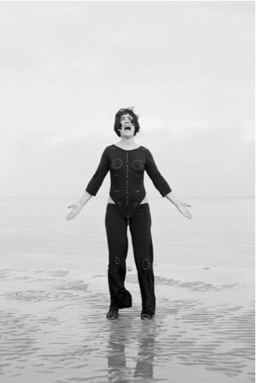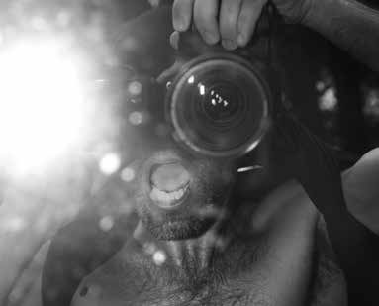
VINST in Dungeness ‘INSPIRATION’ by The Photoperformer, Mexico City (2016)
by Marius Hansen (2005)
image 1 image 2
Emmanuelle and Manuel construct visual metaphors for themselves and for others that they acknowledge as alternative expansion of subjectivity. Aspiring to them and the almost impossible attempt to bring them alive opens up momentary gaps and imaginal spaces that allow them (and sometimes others) to escape prescribed normativity for a while. This led one to become a vocal instrument for all to play (with) with its own peculiar language and system of annotation, and the other a highly trained human apparatus merging body, mind and photo-machine with a stimulated imagination.
Emmanuelle and Manuel resort to breath as a means of bringing life to their posthuman alter egos. They use extreme forms of breathing to reach altered states of consciousness and a certain ‘letting go‘ of the mind that allows them to create such whimsical images in the first place, thus turning imagination into memory and filling the gap between the two with poetry. On being asked to collaborate for these pages, Emmanuelle and Manuel had a sudden desire to become-one in writing and in front of a camera; Em-manuel-le, a new conceptual personae, a speaking, breathing human apparatus hoping to achieve temporary moments of intimate stillness and unity between their body, mind, camera, and surroundings.
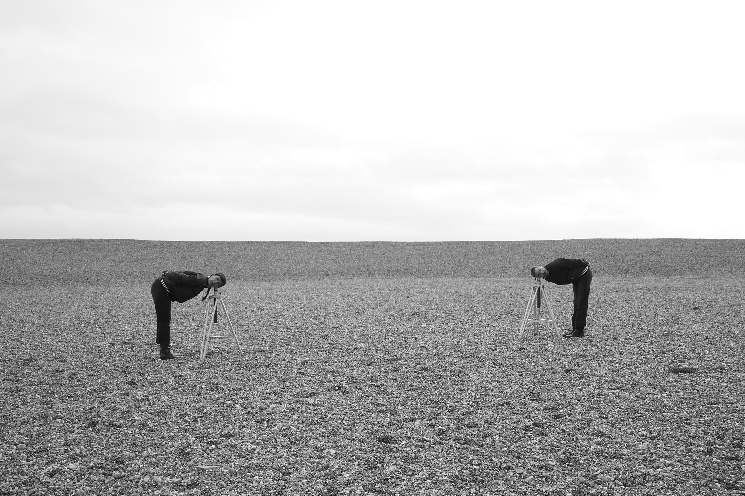becoming-one on the beach, Folkestone, 29 / 01 / 2018 02:36 pm
(DOUBLE PAGE SPREAD)
image 3

becoming-image

‘Becoming’, automatically implies escaping the fixity of photography as the representational art form par excellence. This idea of escaping the inevitable is thrilling and exciting.

Em-manuel-le is interested in a non-representational and repetitive form of photographic gesture that bridges that gap between the photographer, life and its representation (imagination), and to use the photographic medium as a tool for self-expression and participation, rather than as a tool for (self)-representation.
Becoming other implies a movement, a process, a transformation or a feedback.
The act of photographing gives Em-manuel-le a palpable body. Their photographs cannot sweat but their body can while photographing, while vocalising the image.

“ I zoom with my breath, I focus with my heartbeat and I click with my pelvis. I am camera, I am a speaking breathing machine, I make sure I have a heart that beats, that I am only superficially photographic, that I am emotional and manual. Through performing the act of photographing I regain the physical body that I did lose to the photographic image. The camera is a part of my body, I am happily lost in inner travels, in inner songs, lost in observance and celebration of having transgressed my personal borders, part human part machine, not being fully aware of what or who I am, just remembering the instinctive urge to validate my presence in an act of speaking through the camera, a language without words. “
The process of becoming image is appealing to Em-manuel-le; they love to feel light and multilayered. Each image is a repetition, an echo of well-known photographic act, yet this time as the expression of an inner intuitive gesture. The photographs are never an end in themselves, but residual proofs of an impossible gesture, of an encounter with, a place, a person, as well as evidence of personal, existential or conceptual enquiry.
Yet like Echo, Em-manuel-le is bound to multiplicity (every duplication is different from the previous) and they have to touch and be touched to start speaking.
Em-manuel-le never manages to fully escape the surface of the image or the screen and never even imagine that they could exist and operate outside or beyond it, or that experience without subjectivity, or a rational self is possible.
Em-manuel-le no longer feel the desire or need to escape since through a continuous process of photographic and performative self-inquiry they have progressively dissolved the singularity and rigidity of both subjectivity and its image into the invisibility, fluidity and plurality of communication and its modes of activations (writing, listening to, speaking with, touching another).
The desire to escape fixity and isolation is what triggers Em-manuel-le utopian experiments, artificial desires and conceptual actions that even their words cannot always properly express.
Through a photographic act Em-manuel-le happily becomes forever other, the camera recording their constant state of alteration, enacting, projecting their becoming-one. Em-manuel-le’s photography is a relentless mechanism of differentiation (and identification) that produces a never-ending amount of photographic fragments and by doing so it continuously alters any possibility of a stable identity. They lose themselves in an ever-changing hallucinatory mechanical reflection of their repetitive attempt at becoming-one. Their Photography is evolving new qualities, new codes, new programs and is giving life to more and more complex images; performative images whose exposures are determined by the length of their attempt at becoming-one with the camera and their environment through stillness, breathing and an exchange of monotone utterances.
Becoming-one image triggers an insatiable desire to overcome the uncertainty of permanent metamorphosis as well as a craving for the sensation of photographic stability, of being an image, of performing for and with a camera.
Becoming-one signifies engaging in a unlimited-becoming photographic. Maybe it is by considering Photography as a process of becoming and as a repetitive act of transformation that Em-manuel-le can momentarily expand Photography.

“I do think that one of the most pointed paradoxes of our era is precisely the tension between the urgency of finding new and alternative modes of political and ethical agency for our technologically mediated world and the inertia of established mental habits on the other. Donna Haraway put it with customary wit: the machines are so alive, whereas the humans are so inert! “(Haraway, (Haraway, 1991,152; Braidotti, 2013, 58)

Francois Laruelle defines Photography as an ‘hallucination’ and adds: ‘one must understand photography as a practice of the symbolic figuration of ideality or of Being as image’. (Laruelle, 2011, 37)

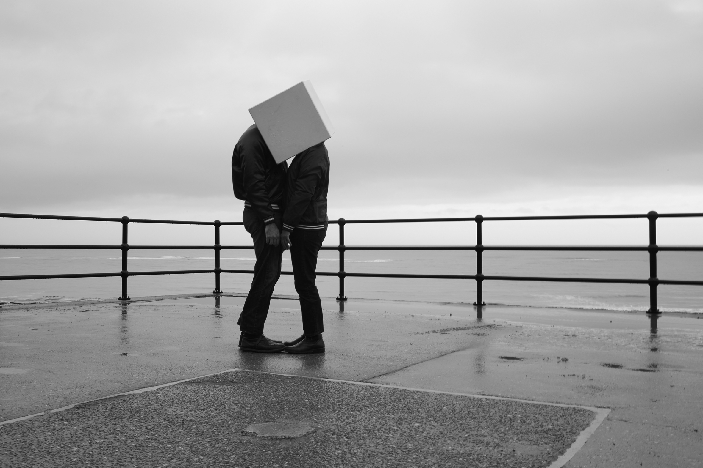
becoming-one on a jetée , Folkestone, 29 / 01 / 2018 03:34 pm
image 4
becoming-one
becoming-one with another in other ways then through writing or sexual bliss.
becoming-one litterally, physically, becoming-one spiritually, emotionally,
becoming-one conceptually, metaphorically.
How can two become one and one what? Headless or mulltiheaded, or both or neither or either or, a mythological being, a cyborg, or a thing made of various bits, part human part something else.
Becoming-one for a moment, connecting body, mind, breath, voice for as long as it takes for the connection to be established, to happen, not happen and until one or both breaks the spell and/or regain oneness.
“ Before I become one with another there is a distance between us, a distance that permits a reflection. While reflecting, I can choose if to concentrate on our similarity or our differences. Both options are relevant. We both have a body, a different one. Most photographs share a mechanism that originates them but every photograph is different from any other / duplicate even though that difference is nearly imperceptible to the human eye. If I look at my body through an enlarger or a microscope I see it made of a large number of cells in constant reproduction. Those cells are like photographs: there are no two alike but they all replicate life. By producing difference, photography replicates life. The repetition of difference creates more difference. Maybe it is by continuing using photography as an algorithm of replication of our differences that I can become-one with the other as I become photographic pixel and image”.

By performing an act of photographing, Em-manuel-le expose the principles that have constructed us. The function of their acts in not to reveal the world but the replicated world that photography is constructing. Aiming at an impossible gesture, they constantly flirt with failure, with utopia and with abstraction. They feel joy when creating a space that escapes control. Living the illusion of this impossible task is allowing them to ‘touch’ their poetic other.
Becoming-one is an exercise of connection and exchange with the intention to bring to life a conceptual image, as an unrehearsed acting out of an idea, brought into focus by all the implicit limitation and friction of the real against the imagined, once actualized in a designated location. A desire to escape control and normativity has triggered us to become photographic gestures. Em-manuel-le standing at the end of Folkestone jetee on a cold rainy afternoon, their head in a wooden cube, eyes closed in the dark, body swaying in the wind, completely engrossed in breathing and humming their wet and shivering oneness, contemplative yet unaware of time passing and the living image they are creating for camera and passers-by alike. A desire to open up, to reach out and connect to another, not for romantic or sexual motives but to experiment with other forms of being in the world and with each other.
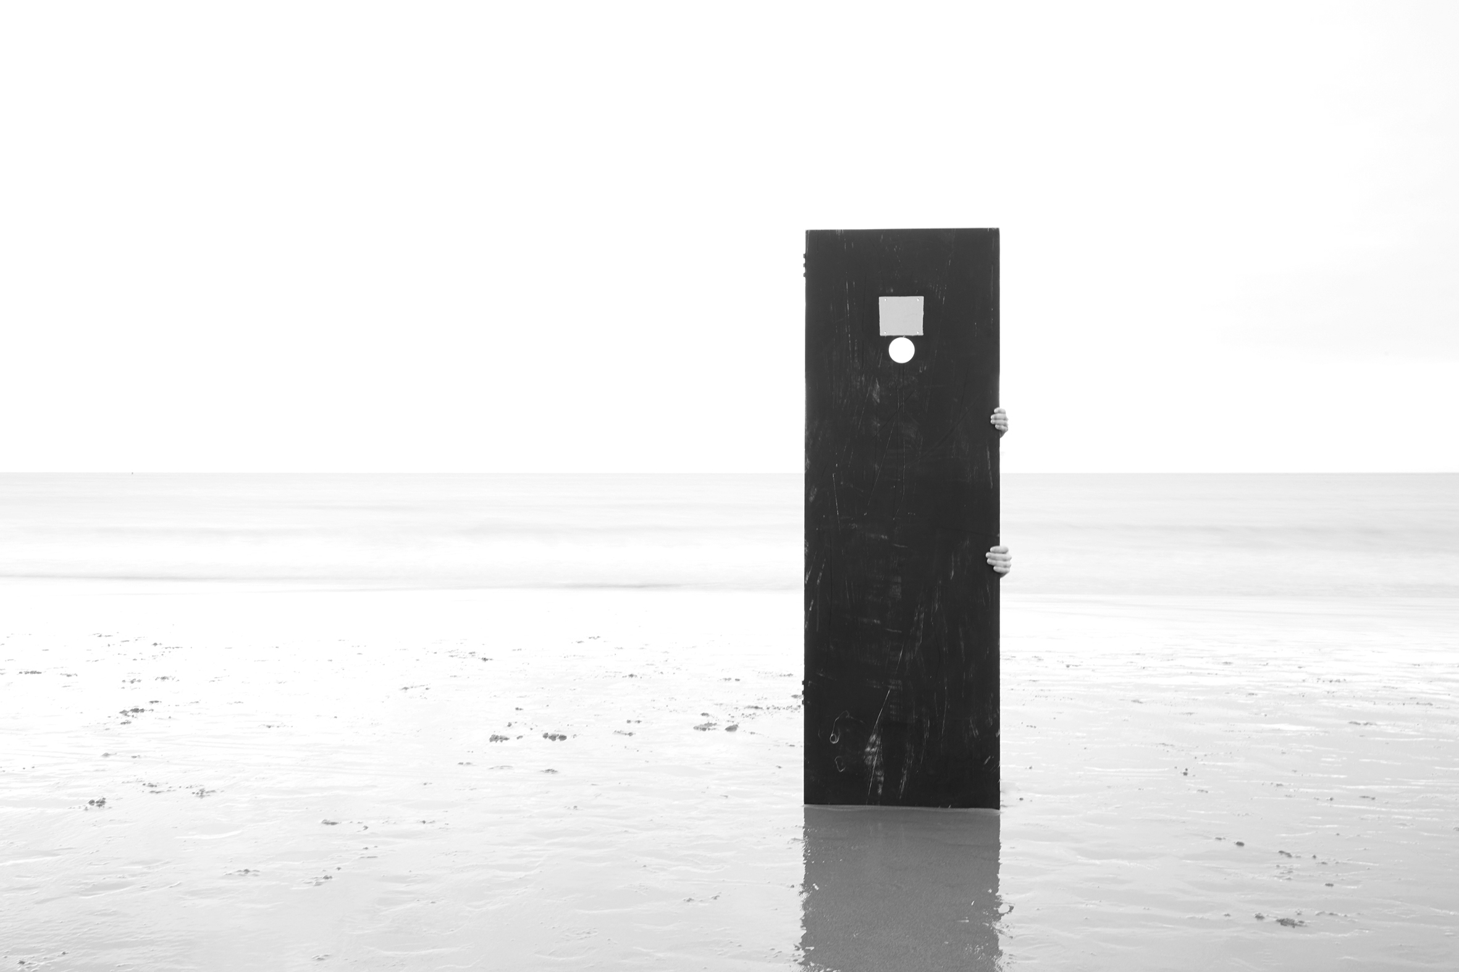
becoming-one on the beach, Folkestone, 28 / 01 / 2018 04:02 pm
image 5

Instructions for two (or more) becoming-one anywhere, indoor or outdoor.

- Find ways to connect your bodies, through touch, sight or other intermediary object or material interface, a plinth, a plank, a string…

- Stand in stillness thus connected, opening up senses, observing, tracking, feeling, listening to your oneness.

- Become aware of breathing, trying to breathe as one.

Become aware of all sounds, join in with your voice, trying to hum as one.

Em-manuel-le loves the sea, the pungent smell of dry seaweed and conversing with seagulls. They spent four days in Folkestone in early 2018 with no other expectations then finding ways to become-one with the camera and with their environment in stillness and in body and mind, excited by the prospect of what they may discover in doing so. They had access to a white cube gallery on the high street, to gather their thoughts and make plans, the basement of which provided them with a few accessoriesthat they instinctively felt attracted to; a wooden box, a level, 2 identical tripods, an old door, a roll of cling film ; so many potential transitional objects with which to connect their body while giving them a possible reason, rather then an excuse, to do so. Duration, hypnosis, meditation, visualisation, breathing and vocalising were discussed as possible ways to expand the body/object connection to the mind. It was then decided that the camera would be set on a tripod and operated by another, so as to not interfere too much with their becoming-one and that the exposure will last for the duration of the thus achieved unity of camera, action, photographer and photographed. It took them a couple of walks to chose the appropriate locations conducive to becoming-one, instinctively picking those where they felt more at ease, which they were pleased to realise were different from those normally found in tourist or cultural brochures of the town, though what they had in common is that in each one of them, sea, sky, natural and build environment were in tacit harmony.

On numerous occasions at these 5 locations, on a sand beach, on a pebble beach, on a cliff edge, in a park, on a jetee, Em-manuel-le became-one, breathing and vocalising with a tripod, a piece of wood, a length of clingfilm, a level, a gesture but also with the photographer, the camera’s shutter: all united for the duration of each exposure of their momentary communion.

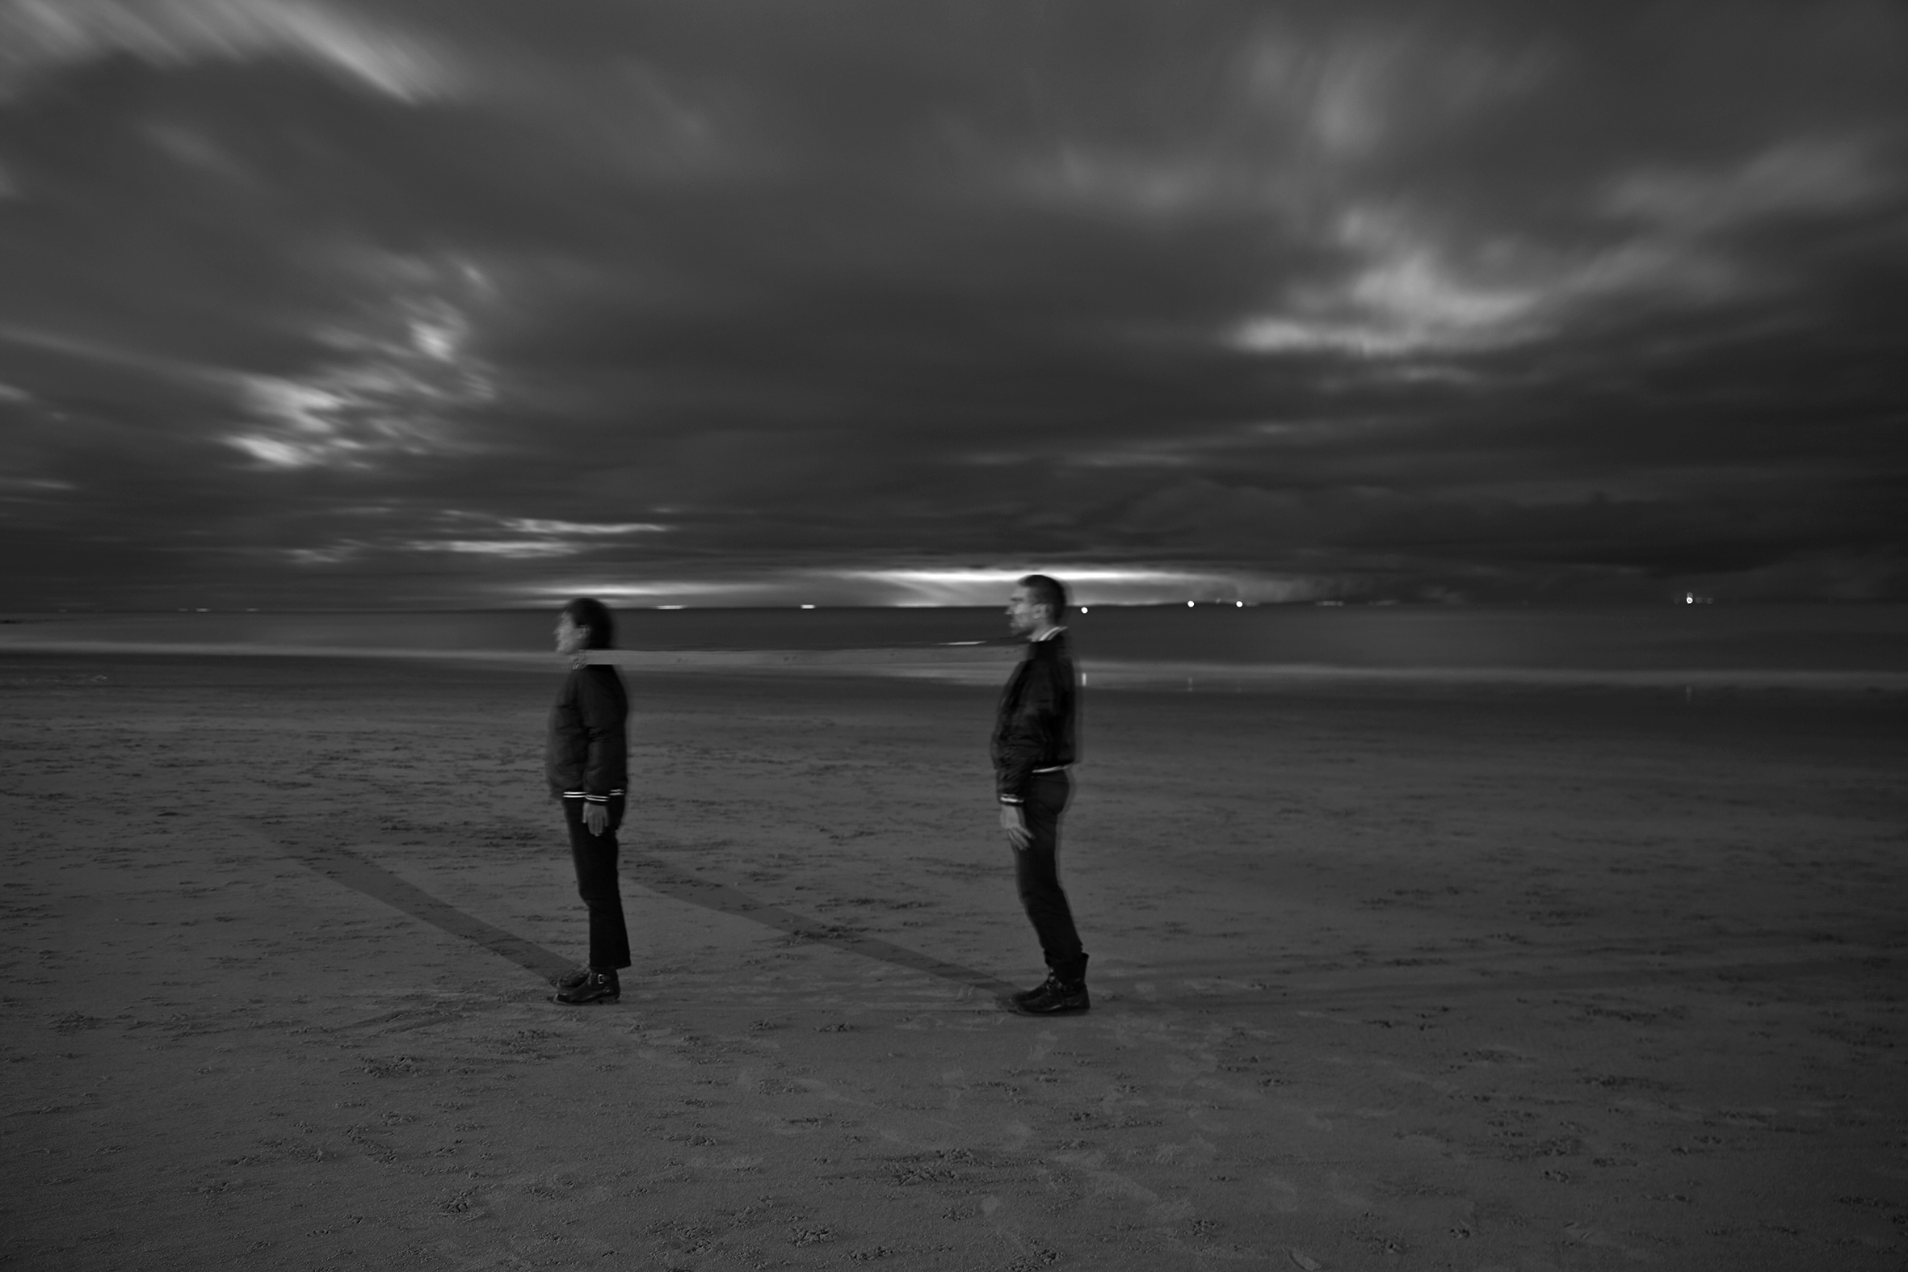
becoming-one in the moon light, Folkestone, 29 / 01 / 2018 05:09 pm
image 6

“ Trying to become one in such way, implies a lot of listening in and out and opening up of all senses to be able to tune in to the other. What happen in this attempt of becoming one for an instant, is a sense of shared intimacy and stillness with each other but also with our surroundings, becoming highly aware of each other’s minute motion and tensions as well as what is happening around us. Often that intimate and fragile connection will be broken, by strong wind, a cramp, an itch, an ache, a fear. Then we start again in our hopeful attempt to reach oneness. In that process of synchronizing, connecting and breathing a way of becoming-one, in stillness, Em-manuel-le became, at ease, intimate even, with their environment, with the world, no more alienation, no more tension… ( even those caused by the instructions) until the overwhelming vastness of their undivided and dissolved self brought them back rather brutally to their own sense of disconnected individuality. Only then could they fully appreciate the extent of their oneness lost and regained.”

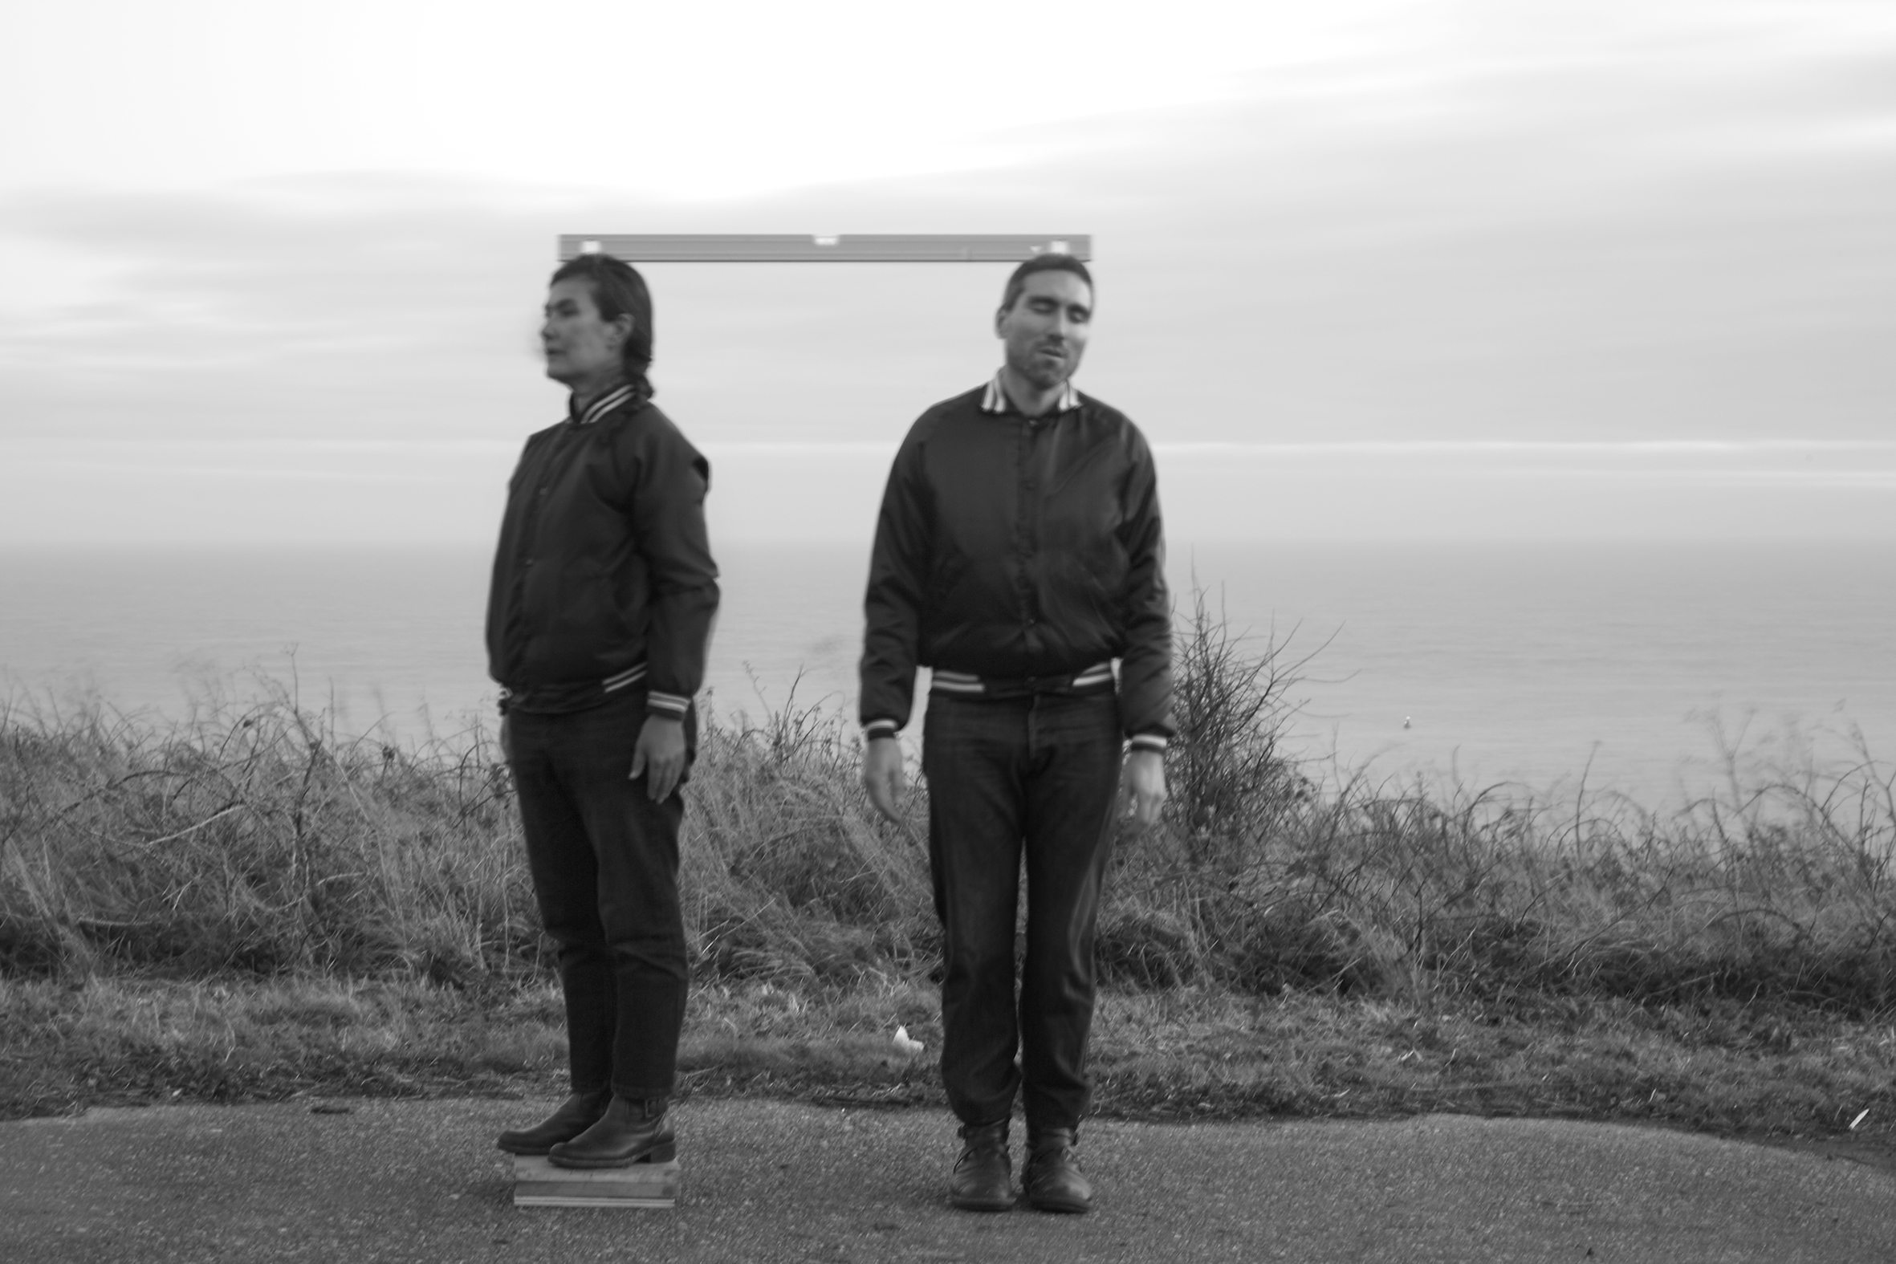
becoming-one in-balance, Folkestone, 28 / 01 / 2018 04:34 pm
image 7
Emmanuelle and Manuel are now sitting at the same desk, next to each other, in front of their respective laptop, frowning and staring at their screen, legs crossed under the table, recollecting how it felt to become-one, to be Em-manuel-le six times in two days, using the various objects and materials they had intuitively and instinctively chosen as connectors and conductors of their oneness. They are using the same gestures on the keyboard, writing in the first singular person, trying to put into words what they can only refer to as fleeting magic moments of deep yet platonic intimacies, knowing that already I has become-one again without becoming we. They question and probe each other, taking turn in transcribing each other’s words as they formulate them.

“ The camera was always there, I was aware of the shutter of the long exposure and the time it took to process it, I could hear it, but this was not the reason I was there, and I was not sure of what would be the outcome of the image and this did not matter. I was concentrating entirely, all my senses, sight, sound, touch, were focussed on the other and the interface that connected us and how we connected with the environment.”

“I am in the image, the content of the image, living and breathing, I am operating a multitude of cameras, not just the one pointing at me, focusing on synching their apertures and shutters, conscious of the shear amount of data they are meant to collect. While focusing on the contact between the image created and the image imagined I am busy operating a number of different photographic cameras pointing at different directions and collecting combinations of time and light. The sea had a camera, the door had a camera, the lamp post had a camera all pointing at us. An imaginary cable release is connecting all the cameras and establishing presence as an action of synchronization. Maybe the aim of the exercise of becoming one is to diversify in the most complex way the synchronicity of our unity.”

Emmanuelle and Manuel attempted to merge their breathing and vibrate as one by creating a continuous variation of sounds, constantly losing and seeking one another by vocalizing and listening. The overwhelming situation of synchronizing with another body, another breath and the multiplicity of their difference provoked a total blackout.

“ I recognise in that blackout the connection of our multiplicity. I also recognise the black screen of the camera’ shutting down, while capturing and processing the infinite amount of information and data in front of it, thus mirroring my mind shutting down in its attempts at a similar task. The long exposure overloaded the camera with information to process and interpolate so the camera underwent a double blackout or maybe an extended blackout… first the hardware then the software. The photographs are a consequence of a specific temporary unconsciousness documenting another temporary unconsciousness of my overwhelmed mind.
Becoming-one grows from a process of losing one-self and by drifting in the intensity of sensation in and out the self. Confronted with the complexity and multiplicity of data my photographic mind lost control and became one with yours. Lost in the conceptual space of our imagination we merged our distances, our reflections and our differences into a variable photographic becoming.”
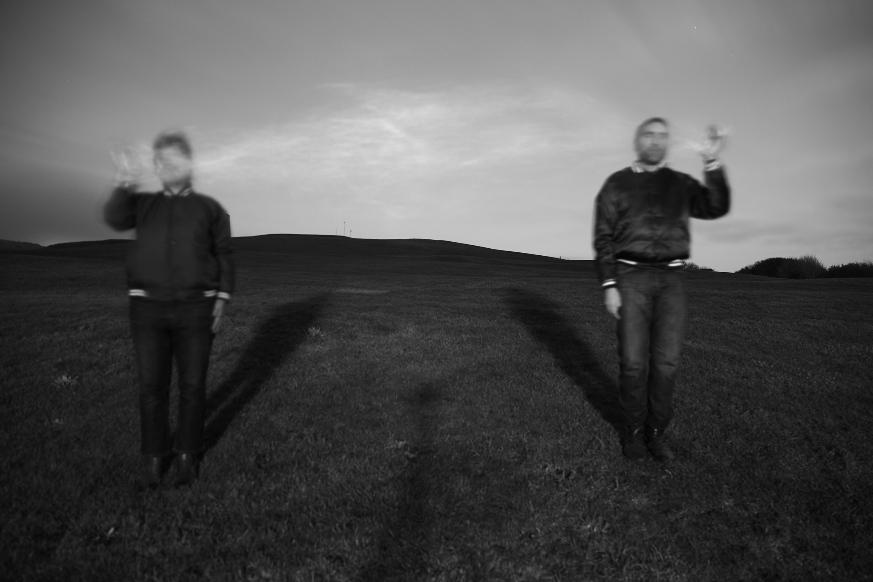becoming-one on in the wind, Folkestone, 28 / 01 / 2018 04:59pm
Image 8
“ We became one in writing and in breathing, in real time and in photographic time. We attempted to merge theatre, photography and life, the images are there to prove it, as well as our memories of the experience and our attempt at sharing, comparing, articulating and putting into words what happened to us individually during these extra-ordinary human and posthuman encounters. Though becoming-one on the page proved less straight forward then doing so in breathing in front of a camera, which felt quite natural and enjoyable to both us, unlike writing.

What matters is that we did become one, for brief moments of shared intimacy and acute concentration of our mind and senses, in our attempt to merge photography, theatre and life. We both felt a certain dissolving of our physical boundaries when merging with our transitional object to become one swaying entity held together by the elements and the tacit agreement of all its parts, human and non-human. Each time we were becoming one with each other and with the entire stage - earth, sea, wind, sky, clouds, concrete, grass, seagulls, passerby, camera, photographer... Yet we did so in our own particular way of merging art and life, one tried to absorb it all and became overwhelmed, fragmented and blacked out as a result, while the other, let herself be absorbed by it all, dissolving a bit more at each breath. In both cases we did achieve a certain form of temporary fluidity of our being, from a fragmented I, Manuel and Emmanuelle, to a collective Em-manuel-le, full of fruitful difference and tension, yet acting out in unison their desire to seek out and create new forms and expressions of being together in harmony with the world, on and off the page, with or without a camera, for themselves and perhaps for others too.”

Post Scriptum:

During one last look at the photographs created, I focus on their two-dimensional perspective, on their ontological formula that places in relationship two (and more) aspects, measuraments and lengths. If every photograph is the result of a relationship between different lengths (of space and time), our experiment has proven that becoming-one is always an approximation. Our differences are reflected not only on the diversity of our point of views but also on the weight of our contributions and on our profoundly unitary ambivalence.

Reference list

Braidotti, Rosi. 2013. The Posthuman. Cambridge: Polity press

Haraway, Donna. 1991. Simians, Cyborgs and Women: The Reinvention of Nature. New York: Routledge

Laruelle, Francois. 2011. The Concept of Non-Photography. New York: Sequence Press

It was totally unpredicted and fortuitous that the person operating the camera was Ernst Fischer; a friend and a great performance artist based in Folkestone.

