Dress Talks – Spring 2018
23rd February 2018
12.30-1.30pm

Nita Harvey’s Archive: the role of clothes in the life and career of an English actress (c.1930)

Event Description
Four years ago Ellen Nolan inherited a suitcase. Inside was an archive of hundreds of images and documents belonging to her Great Aunt, Nita Harvey, an English actress on the brink of Hollywood success in the 1930s. In 1933 Nita was discovered through a beauty contest, summoned to Hollywood and signed to Paramount studios. She was prepared for performing by her mother, who constantly photographed her. Ellen has been working with the archive to create a dialogue between the performativity of the domestic portraits of Nita taken by her mother and family, and the professional industry images taken by Paramount Studio photographers. This paper will discuss the role of clothes in Nita’s life and career, and their function in the archive.

Speaker Bio

Ellen Nolan is an artist and Senior Lecturer in Photography and Fashion Photography at the University for the Creative Arts, Rochester. She was previously a photography lecturer at the London College of Fashion. Her research focusses on aspects of representation and performativity in commercial and domestic family photography. It considers the use of photography as a means of exploring the act of representation as a meditation on photography and image performance. Ellen worked as a successful fashion and portrait photographer and regular contributor over a 15-year period to magazines, including British Vogue, i-D, Purple and The Sunday Telegraph. She has shot major fashion advertising campaigns for Dries Van Noten, Levis, Nike and Eley Kishimoto. She also directed pop videos and shot album covers for Beth Orton, amongst other international artists. She continues to work for and collaborate with British fashion designer Margaret Howell. Her work has been exhibited internationally, including at The Photographers Gallery, Arles Festival and The National Portrait Gallery in London, where her work is part of their National Collection.
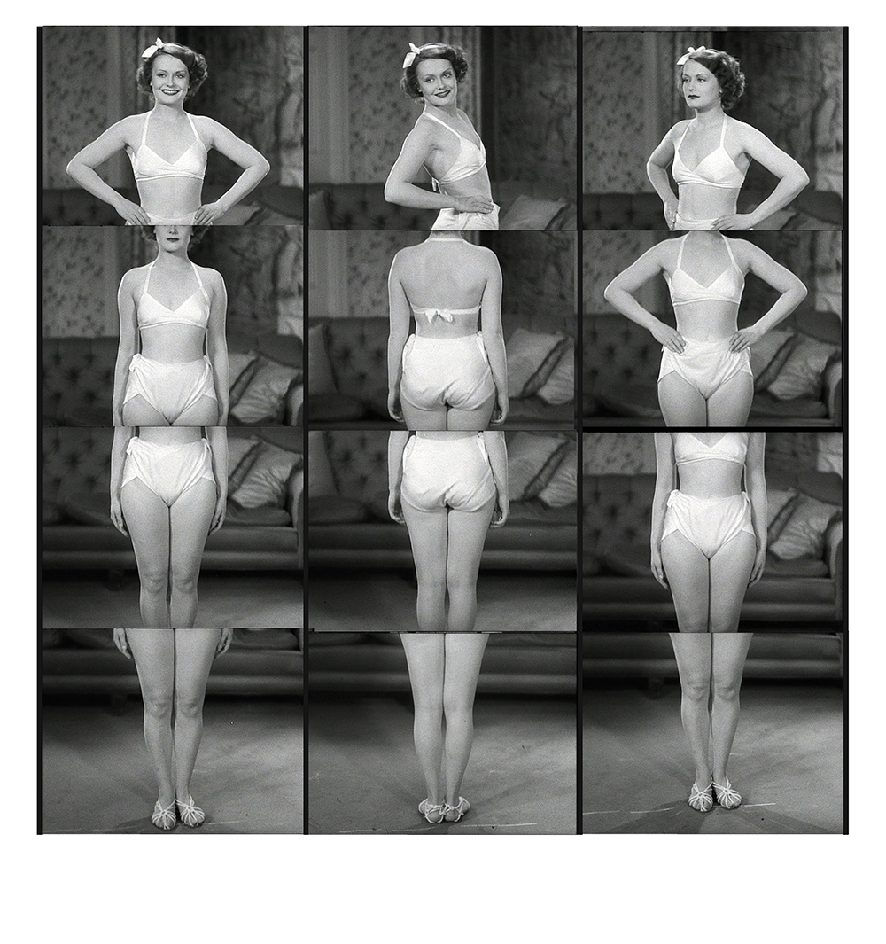
Casting Couch (Film stills). © Ellen Nolan 2017

